old man’s beard

  - Clematis vitalba
Buttercup Family
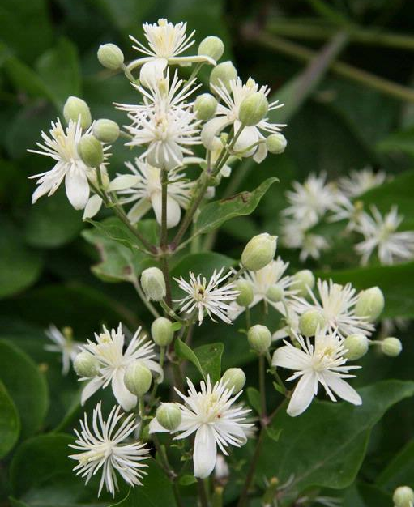

INTRODUCTION

Identification Tips

Old man’s Beard is a perennial, woody, deciduous vine, climbing trees or brush, or acting as a groundcover in the absence of something to climb.
- Compound leaves are opposite and have 5 leaflets, appearing smooth (primarily) or rarely toothed.
- Small, white, perfect (having both female and male parts on each flower) flowers cluster in upper leaf axils and bloom in summer.
Photo by: Robert Videki, Doronicum Kft., Bugwood.org
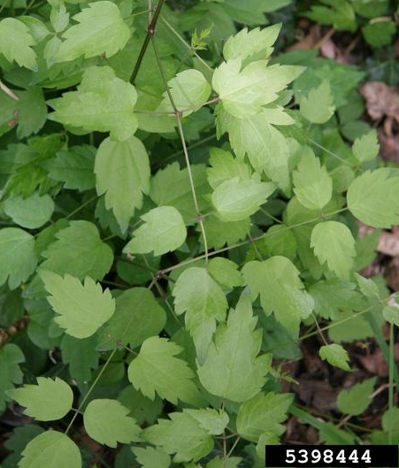
- Seeds are gray achenes with long, feathery appendages which give them a fluffy cotton-like appearance. They persist long into the fall or winter.

Look-A-Likes
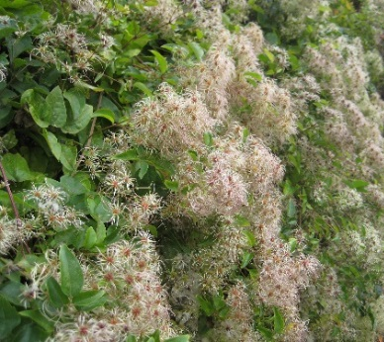
- Western white clematis (Clemtis ligusticifolia) is a native clematis that looks very similar to C. vitalba. Unlike the invasive clematis’ perfect flowers, western white clematis has male or female flowers (not both) and the leaves are generally toothed (as opposed to mostly smooth on the invasive clematis). Seed tend to disperse readily and do not persist through the winter. The growth habit of western white clematis is much less aggressive than its invasive counterpart. Also, western white clematis is primarily found in the eastern parts of Oregon and Washington, while the invasive is primarily found on the west side of the Cascades.
Photo by: Robert Videki, Doronicum Kft., Bugwood.org

Impacts
- Old man’s beard prevents bushes and trees from receiving sunlight and much like other invasive vines such as ivy, clematis adds considerable weight to trees, eventually weakening them and making them more susceptible to wind throw.
- Dense thickets of old man’s beard impact surrounding vegetation, smothering critical understory plants.

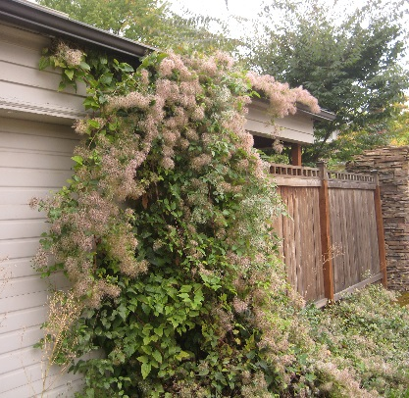
Habitat & Distribution
- Old man’s beard is found primarily on the west side of the Cascades.
- It can grow in a wide range of conditions, from dry to moist soils and in full sun to part shade.
- Suitable habitats for invasive clematis include riparian and upland forests, urban yards and parks, and any disturbed site such as roadsides.

Reproduction & Spread
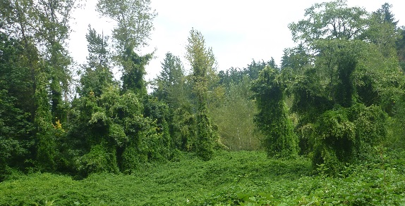
- Old man’s beard reproduces primarily by seed dispersed via wind and water.
- Cut stems can also re-sprout, allowing the vine to reproduce vegetatively.
- Seeds can remain viable in the soil for up to 5 years in the soil.

CONTROL INFORMATION

Integrated Pest Management
- The recommended approach for weed control is Integrated Pest Management (IPM). IPM involves selecting from a broad range of control methods to strengthen the impact of management practices given the ecology of the pest and the specific site conditions where it occurs. The goal of IPM is to maximize effective control and to minimize negative environmental, economic, and recreational impacts.
- Use a multifaceted and adaptive approach. Select control methods reflecting the available time, funding, and labor of the participants, the land use goals, and the values of the community and landowners. Management may require dedication for a number of years and should allow flexibility in methods.

Planning Considerations
- Survey area for weeds, set priorities, and select the best control method(s) for the site.
- Control practices should be selected to minimize soil disturbance. Minimizing disturbance prevents further infestations of weeds.
- Begin work on the perimeter of the infested area first and move inward toward the core of the infestation.
- Monitor the site and continue to treat plants that germinate from the seed bank.
- Revegetate the treatment areas to improve ecosystem function and prevent new infestations.

Early Detection and Prevention
- Old man’s beard is easily identifiable throughout the year, with the leafless vines visible in winter.
- Control new infestations as early as possible, and prevent plants from flowering and setting seed.
- Minimize soil disturbance from vehicles, machinery, and over-grazing to reduce seed germination.
- Monitor for new plants and re-treat as necessary. Ensure any existing plants do not produce and release seed.
- Prevent the additional spread of invasive species by thoroughly cleaning tools, boots, and vehicles after working in or traveling through an infested area.

Manual, Mechanical, & Cultural Control
- For small infestations of vines growing on the ground, pull or dig plants and roots when the soil is moist. Remove as much of the roots as possible to keep them from re-sprouting.
- For vines growing in trees, separate the vines from the roots by cutting the vine several feet above the ground. Pull or dig all plant parts below your cut.
- Dispose of all plant parts in the garbage to discourage re-sprouting.
- Sheep will feed on seedlings and young vines at ground level, but plants can be poisonous to other livestock.

Herbicide Control
- Only apply herbicides at proper rates and for the site conditions or land usage specified on the label. Follow all label directions and wear recommended personal protective equipment (PPE).
- Treated areas should not be mowed until after the herbicide has taken effect and weeds are brown and dead.
- Monitor treated areas for missed and newly germinated plants. Selective herbicides are preferred over non-selective herbicides when applying in a grassy area.
- Minimize impacts to bees and other pollinators by controlling weeds before they flower. If possible, make herbicide applications in the morning or evening when bees are least active. Avoid spraying pollinators directly.

Specific Herbicide Information
Herbicides are described here by the active ingredient. Many commercial formulations are available containing specific active ingredients. References to product names are for example only. Directions for use may vary between brands.

- Make a foliar application of glyphosate (e.g., Roundup) after full leaf development and when the plant is actively growing. This herbicide may take several weeks to show signs of damage or mortality.
- Make a foliar application with triclopyr (e.g., Vastlan, Ortho Max Poison Ivy, and Tough Brush Killer) when the plants are actively growing. This herbicide is recommended when desirable grasses are present.
- For large vines, use a cut stump treatment. Cut the vine close to the ground and apply the herbicide to the cut surface. Consult the herbicide label for the appropriate rate for cut stump treatments.
- Continuously monitor for new plants, especially following any disturbance to the soil such as tilling or construction.

  - This BMP does not constitute a formal recommendation. When using herbicides, always consult the label. Please contact your local weed authority for more information.

Additional Resources

https://www.cabi.org/isc/datasheet/14280

http://columbiagorgecwma.org/weed-listing/best-management-practices/clematis/

http://hortsense.cahnrs.wsu.edu/Home/HortsenseHome.aspx

https://your.kingcounty.gov/dnrp/library/water-and-land/weeds/Brochures/Old-Man's-Beard-Clematis-vitalba-Weed-Alert.pdf

http://www.nwcb.wa.gov

http://wric.ucdavis.edu/information/natural%20areas/wr_C/Clematis.pdf

http://biology.burke.washington.edu/herbarium/imagecollection.php?ID=3682

