False Brome

  - Brachypodium sylvaticum
Grass Family

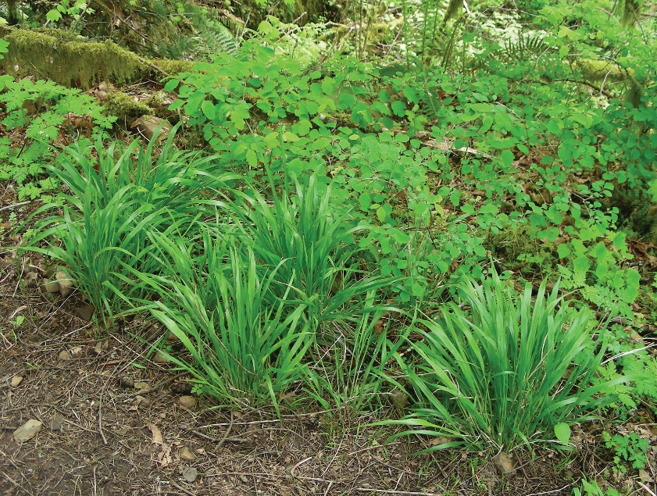
INTRODUCTION

Identification Tips
- False brome is a perennial bunch grass that stays green throughout the year. Mature stands form solid mats of plants 12 to 18 inches tall.
- The leaf blade is flat and lax (floppy), 1/4 to 1/3 inch wide, and distinctively bright green.
- When held up to the sky, a fringe of fine hairs is easily seen around the margin of the leaf.
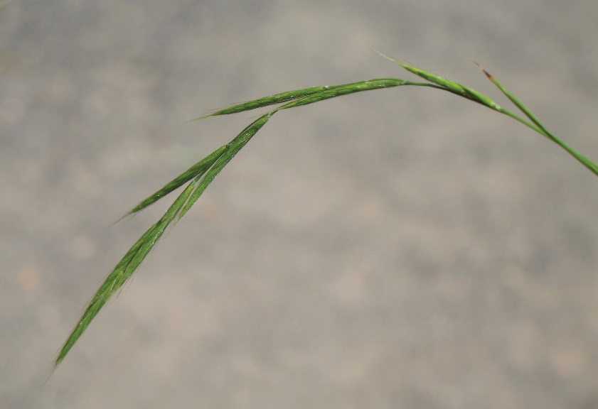
- The lower stem is thickly covered with fine, even hairs. The sheath is open and freely releases the stem when pulled back.
- Flower spikelets droop and have no stalks. False brome blooms between June and September.
Identity of false brome should be confirmed by a weed specialist as this species is easily confused with native grasses.

Impacts
- Thick mats of false brome inhibit native plant establishment, displace established wildlife, and inhibit tree seedlings, impacting regrowth after logging.
- In commercial forests, false brome creates the perfect habitat for rodents that damage tree seedlings.
- This grass also appears to be fire-resistant, re-sprouting within 2 weeks of a burn. It may increase fire risk.
- Efforts to restore fish habitats may be impaired when false brome is present as it reduces establishment of planted riparian trees that provide shade and structure to streams.

Habitat & Distribution
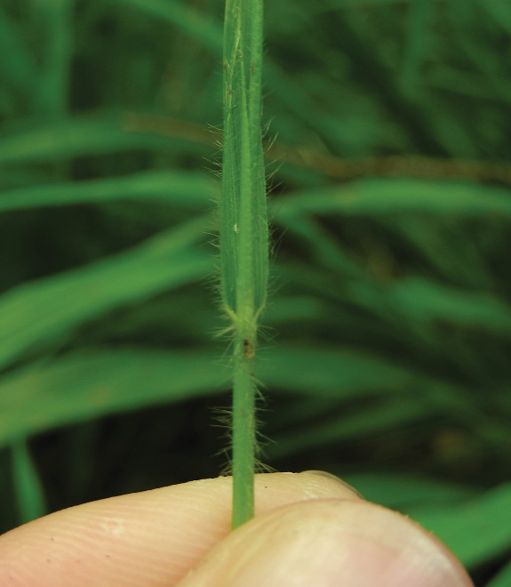
- False brome grows well in shade or sun, in moist or dry soils, and from low elevations up to about 3500 feet.
- Increases in atmospheric nitrogen due to human activity can give fast-growing false brome an edge over native competitors.

Reproduction & Spread
- False brome reproduces through seed production, producing up to a couple hundred seeds per plant. Seeds appear to be fairly short-lived.
- Self-fertilization allows populations to establish from a small number of seeds.
- Awned seeds attach to animals, humans, and vehicles.
- While plants do not spread from rhizomes, false brome can re-sprout from stems or small root fragments when cut.

CONTROL INFORMATION

Integrated Pest Management
- The preferred approach for weed control is Integrated Pest Management (IPM). IPM involves selecting from a range of possible control methods to match the management requirements of each specific site. The goal is to maximize effective control and to minimize negative environmental, economic, and recreational impacts.
- Use a multifaceted and adaptive approach. Select control methods reflecting the available time, funding, and labor of the participants, the land use goals, and the values of the community and landowners. Management will require dedication for a number of years and should allow flexibility in methods.

Planning Considerations
- Survey the area for weeds, set priorities, and select the best control method(s) for the site.
- Control practices should be selected to minimize soil disturbance. Minimizing disturbance prevents further infestations of weeds.
- Begin work on the perimeter of the infested areas first and move inward toward the core of the infestation.
- Monitor the site and continue to treat plants that germinate from the seed bank.
- Revegetate treatment area to improve ecosystem function and prevent new infestations.

Early Detection and Prevention
- Watch for new patches of this plant, especially after other grasses have started to turn brown.
- Prevent the additional spread of false brome by thoroughly cleaning tools, boots, and vehicles after working in or traveling through an infested area.
- Minimize soil disturbance from vehicles, machinery, and over-grazing to reduce areas where weeds may become established.
- After treatment, monitor and re-treat as necessary. Ensure any existing plants do not produce and release seed.

Manual, Mechanical, & Cultural Control
- Small, isolated patches can be dug out before they produce seed. Extreme care must be taken to ensure removal of all root fragments.
- Mowing alone appears to be ineffective, but mowing used as a pre-treatment to herbicide application can be effective. Mowing must be done before seeds become viable to exhaust the short-lived seed bank. If native or rare species are present, they should be allowed to go through the reproductive cycle, if possible, before mowing.
- Prescribed burning has not been an effective control method. In fact, false brome is frequently found in recently burned sites.
- Prevent the spread of invasive plants by thoroughly cleaning tools, boots, and vehicles (especially mowers) after working in or traveling through an infested area.

Biological Control
- There are no biological agents available at this time.

Herbicide Control
- Only apply herbicides at proper rates and for the site conditions or land usage specified on the label. Follow all label directions and wear recommended personal protective equipment (PPE).
- For control of large infestations, herbicide use may be effective either alone or in combination with mowing. Treated areas should not be mowed until after the herbicide has taken effect and weeds are brown and dead.
- Monitor treated areas for missed or newly germinated plants.
- Minimize impacts to bees and other pollinators by controlling weeds before they flower. If possible, make herbicide applications in the morning or evening when bees are least active. Avoid spraying pollinators directly.

Specific Herbicide Information
Herbicides are described here by the active ingredient. Many commercial formulations are available containing specific active ingredients. References to product names are for example only. Directions for use may vary between brands.
- Infestations can be sprayed with a non-selective systemic herbicide such as glyphosate (e.g. Roundup) from early summer through fall or after the rainy season begins in fall. However, the best time to treat false brome is in June, when the flower is present for identification, but prior to seed set.
- A combination of mowing in early July followed with a fall treatment of glyphosate is also effective. Plants must be mowed prior to seed set.
- Follow-up is critical to successful eradication of false brome. Monitor and treat the infested area each year for several seasons in order to exhaust the seed bank and ensure all plants are eradicated. Visit the site in early summer before plants set seed.
- Permits may be required to make herbicide applications in a wetland.

  - This BMP does not constitute a formal recommendation. When using herbicides, always consult the label. Please refer to the Pacific Northwest Weed Management Handbook or contact your local weed authority.

Resources

http://columbiagorgecwma.org/weed-listing/best-management-practices/false-brome/
http://appliedeco.org/resources/invasive-species/fbwg/
http://extension.wsu.edu/whitman/2013/11/false-brome

http://www.kingcounty.gov/services/environment/animals-and-plants/noxious-weeds/weed-identification/false-brome.aspx

http://www.nwcb.wa.gov

http://wiki.bugwood.org/Brachypodium_sylvaticum

http://wric.ucdavis.edu/information/natural%20areas/wr_B/Brachypodium_sylvaticum.pdf

