Indigobush

  - Amorpha fruticosa
Pea Family

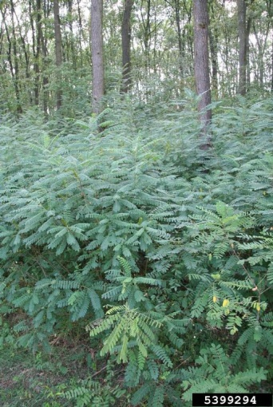
INTRODUCTION

Identification Tips
- Indigobush is a perennial shrub in the legume family.
- It is a thornless, deciduous, multi-stemmed shrub with firm, woody branches growing 4’ to 12’ tall, growing about twice as wide as it is high.
- Compound leaves are made up of 13-25 leaflets which are one to two inches long. They are gland-dotted and hairy with smooth margins.
- Flowers occurs from spring to summer and form dense, upright clusters in the upper branches. They are blue-violet to dark purple and have 10 stamens.
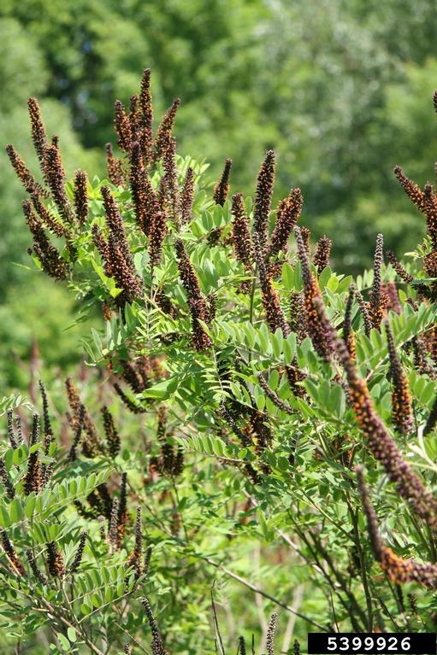
- Seeds form in kidney-shaped seed pods, each about ¼ inch long and containing 1-2 seeds.

Impacts
- Indigobush displaces native plant communities, particularly in wet areas.

It forms dense thickets along shorelines, shading native habitat, affecting hydrology and often impeding recreational access.

Habitat & Distribution
- Indigobush has an extensive root system which has been used for bank stabilization, erosion control, and windbreaks.
- It tolerates poor site conditions.
- It forms dense thickets along waterways, riparian areas, prairie draws, and in moist, upland locations.
- It is commonly found growing in sand and rocks, including rip rap, along waterways.

Reproduction & Spread
- Indigobush reproduces by seed and vegetatively by suckers and plant fragments.
- In favorable conditions, seeds are viable for 3-5 years.
- Seeds move downstream in water or stick to people, animals, or equipment.

CONTROL INFORMATION

Integrated Pest Management
- The preferred approach for weed control is Integrated Pest Management (IPM). IPM involves selecting from a range of possible control methods to match the management requirements of each site. The goal is to maximize effective control and to minimize negative environmental, economic, and recreational impacts.
- Use a multifaceted and adaptive approach. Select control methods reflecting the available time, funding, and labor of the participants, the land use goals, and the values of the community and landowners. Management will require dedication for a number of years and should allow flexibility in methods.

Planning Considerations
- Survey the area for weeds, set priorities, and select the best control method(s) for the site.
- Select control practices that minimize soil disturbance. Minimizing disturbance prevents further infestations of weeds.
- Start work on the perimeter of the infested areas first and move inward toward the core of the infestation.
- Monitor the site and continue to treat plants that germinate from the seed bank.
- Revegetate treatment areas to improve ecological function and prevent new infestations.

Early Detection and Prevention
- Small seedlings can be pulled in moist soil.
- Dispose of cut material properly. Stems can root in moist soil.

Manual, Mechanical, & Cultural Control
- Seedlings or small plants can be removed by hand. This is generally not effective on older plants.
- Indigobush is difficult to control mechanically as it vigorously resprouts from root crowns. It is not rhizomatous, so it can be controlled by repeated defoliation and digging and severing the root 3-4 inches below the crown.
- Mowing of this woody species is usually not an option, although stems can be cut in midsummer to decrease seed production and limit the spread.

Disposal
- Dispose of debris properly; stems may take root if disposed of on moist ground. Remove seed pods to prevent seeding out after stems are cut.

Herbicide Control
- Apply herbicides at proper rates and for the site conditions or land usage specified on the label. Follow all label directions and wear recommended personal protective equipment (PPE).
- Choose selective herbicides over non-selective herbicides when applying in a grassy area.
- Minimize impacts to bees and other pollinators by controlling weeds before they flower. When possible, make herbicide applications in the morning or evening when bees are least active. Avoid spraying pollinators directly.

Specific Herbicide Information
Herbicides are described here by the active ingredient. Many commercial formulations are available which contain specific active ingredients. References to product names are for example only. Directions for use may vary between brands.
- Since indigobush frequently grows in wet areas, only aquatic-approved herbicides are allowed in many situations. As with all herbicide use, be sure to read and follow all label instructions and to abide by all state regulations. Permits may be required to make herbicide applications in a wetland.
- Use glyphosate (Rodeo) as a foliar spot treatment when leaves are fully emerged. Thoroughly moisten all leaves without creating run-off.
- If plants are large, cutting the stems a foot above the ground and spraying the regrowth (a month later) will reduce the amount of herbicide used and overhead spraying needed.
- For cut-stump treatments, cut stems horizontally at or near ground level, and immediately apply herbicide solution. Cut-stump treatments use an undiluted glyphosate concentrate. Stump treatments can occur anytime, but late summer or early fall is recommended.

  - This BMP does not constitute a formal recommendation. When using herbicides, always consult the label. Please refer to the Pacific Northwest Weed Management Handbook or contact your local weed authority.

Resources
http://columbiagorgecwma.org/weed-listing/best-management-practices/indigobush/
http://extension.wsu.edu/whitman/2013/11/indigobush/
http://www.nwcb.wa.gov/weeds/indigobush
http://www.nwcb.wa.gov/images/weeds/Indigo_bush.pdf
http://wric.ucdavis.edu/information/natural%20areas/wr_A/Amorpha.pdf

