purple loosestrife

  - Lythrum salicaria
Loosestrife Family
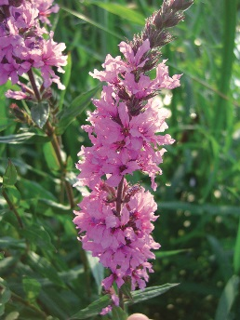

INTRODUCTION

Identification Tips

Purple loosestrife is an herbaceous perennial growing up to 10 feet tall with up to 50 stems per plant.
- An aquatic emergent with a well-developed, woody taproot as well as fibrous, rhizomatous roots, purple loosestrife establishes in massive thickets in shallow standing water and in moist areas.
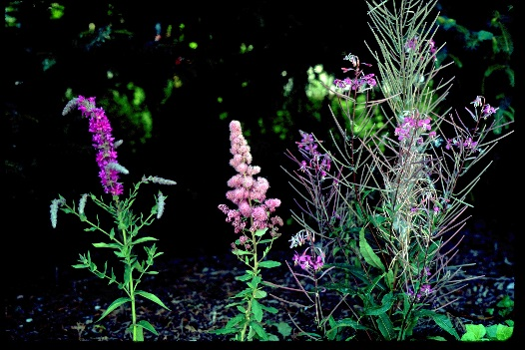
- Downy, lance-shaped leaves appear in whorls, opposite, or alternate and clasp with no stalks to a 4 to 6-sided, upright stem.
- Clusters of numerous, showy, pink to purple flowers with 5 to 7 petals bloom on upright spikes from July to September.
- Countless seeds the size of sand grains are dispersed in the fall.
- Purple loosestrife can be confused with the native plants spiraea and fireweed. Spiraea douglasii is a woody shrub with round stems that contain leaves with toothed tips. Light pink flowers appear in clusters at the top of the plant from June to August. Fireweed (Epilobium angustifolium) has a round stem and its pink flowers have 4 petals. Fluffy white seeds are released from long capsules to blow in the wind.
L to R: purple loosestrife, native spiraea, native fireweed; photo King County NWCP

Impacts
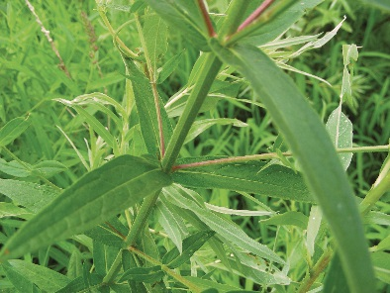
- Purple loosestrife quickly spreads and displaces native wetland and riparian vegetation needed by wildlife for food, nesting, and cover.
- Decreased waterfowl and songbird production has been well documented in heavily infested marshes. Purple loosestrife has also been linked to a reduced development or survival rate in certain amphibian species as a result of a change in the food web because of differences in nutrients between purple loosestrife and native vegetation. ¹
- Besides impacting wildlife, purple loosestrife clogs irrigation canals and drainage ditches, impeding water flow.
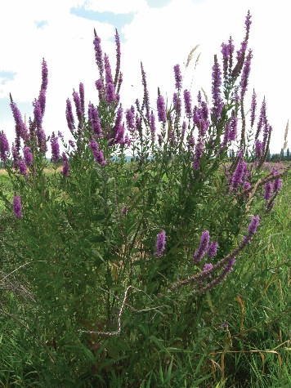

Habitat & Distribution
- Native to Europe, Asia, Australia, and Northern Africa, purple loosestrife was introduced via ship ballast and as an ornamental plant.
- It prefers freshwater or brackish wetlands, streams, ponds, and marshes, but it can be found in drier sites particularly around pastures and fields.

Reproduction & Spread
- Purple loosestrife can spread vegetatively by stem fragments and root rhizomes or by over 2 million seeds produced by a single mature plant.
- Seeds are dispersed by wind and can float in water.

CONTROL INFORMATION

Integrated Pest Management
- The recommended approach for weed control is Integrated Pest Management (IPM). IPM involves selecting from a broad range of control methods to match the management requirements of each specific site. The goal is to maximize effective control and to minimize negative environmental, economic, and recreational impacts.
- Use a multifaceted and adaptive approach. Select control methods reflecting the available time, funding, and labor of the participants, the land use goals, and the values of the community and landowners. Management will require dedication for a number of years and should allow flexibility in methods.

Planning Considerations
- Survey area for weeds, set priorities, and select the best control method(s) for the site.
- Control practices should be selected to minimize soil disturbance. Minimizing disturbance prevents further infestations of weeds.
- Begin work on the perimeter of the infested area first and move inward toward the core of the infestation.
- Monitor the site and continue to treat plants that germinate from the seed bank.
- Revegetate the treatment areas to improve ecosystem function and prevent new infestations.

Early Detection and Prevention
- Purple loosestrife is easily identifiable in the summer months.
- Control new infestations as early as possible.
- Minimize soil disturbance from vehicles, machinery, and over-grazing to reduce seed germination.
- Monitor for new plants and re-treat as necessary. Ensure any existing plants do not produce and release seed.
- Prevent the additional spread of invasive species by thoroughly cleaning tools, boots, and vehicles after working in or traveling through an infested area.

Manual, Mechanical, & Cultural Control
- If plants are in flower or seed, cut and bag all flower stalks and seed heads and dispose of it in the garbage.
- When plants are young and rooted in mud or sand, hand pull the stem close to the ground and uproot the root ball. Be sure to monitor the work area for large root fragments which, when left in the ground, can sprout into new plants.
- Cutting alone will not kill purple loosestrife. Cutting may decrease flower and seed production, but continual monitoring of new or re-sprouted plants is necessary. Plant parts should be disposed of in the garbage or dried completely to avoid new plants growing from root or stem fragments.
- Sheet mulching or covering purple loosestrife is a short-term option to decrease the growth rate and seed dispersal. To be effective, the covering must extend several feet beyond the infestation edge and be weighted to discourage plant growth. Monitor the covering material to ensure gaps are covered and new plants are not growing beyond the edge. Follow-up in year two with a more viable control option.
- Purple loosestrife is a prolific seed producer and seeds could be viable up to 20 years. Any treatment will require monitoring and follow-up for many years.

Biological Control
Non-native plants easily establish large infestations and become widespread in their introduced range because they have no natural enemies as they do in their native range. Biological control deliberately reunites a species with its natural enemies, including insects and pathogens, in hopes of achieving the balance found in the plant’s native range. Biological control is not available for all species and will only reduce seed production or the size of the infestation, not eradicate it. It is generally most effective when used in conjunction with other control techniques.
- There are several agents that effectively control purple loosestrife in our area. Galerucella calmariensis and G. pusilla are foliage feeding beetles whose larvae and adults consume the foliage of the plant, therefore making it impossible for the plant to photosynthesize. These beetles cannot be used where mowing occurs and they often cannot establish in areas where the water level surrounding the loosestrife fluctuates (tidal or dam influence).
- A root-feeding weevil, Hylobius transversovittatus, and a flower/bud-feeding weevil, Nanophyes marmoratus, have also been released in the Pacific Northwest as biological control agents for purple loosestrife. These two weevils are more difficult to collect and therefore not widely available.

Herbicide Control
- Only apply herbicides at proper rates and for the site conditions or land usage specified on the label. Follow all label directions and wear recommended personal protective equipment (PPE).
- For effective control of large infestations, herbicide use may be necessary. Cutting after an herbicide treatment is not needed. However, if cutting is desired, treated areas should not be mowed until after the herbicide has taken effect and weeds are brown and dead.
- Monitor treated areas for missed and newly germinated plants. Selective herbicides are preferred over non-selective herbicides when applying in a grassy area.
- Minimize impacts to bees and other pollinators by controlling weeds before they flower. If possible, make herbicide applications in the morning or evening when bees are least active. Avoid spraying pollinators directly.

Specific Herbicide Information
Herbicides are described here by the active ingredient. Many commercial formulations are available containing specific active ingredients. References to product names are for example only. Directions for use may vary between brands.

- Triclopyr (e.g., Vastlan, Ortho Max Poison Ivy, and Tough Brush Killer) – Apply throughout the growing season to foliage, covering the plant completely, but avoiding runoff. Triclopyr selectively targets broadleaf plants and typically leaves grasses and other monocots unharmed.
- Glyphosate (e.g, Aquamaster or AquaNeat) – Apply to foliage (but avoid runoff) of actively growing plants. Caution: glyphosate is non-selective herbicide and will injure or kill other vegetation contacted by the spray.
- Imazapyr (e.g., Habitat or Polaris) – Apply to foliage of actively growing plants. Caution: imazapyr is non-selective and highly effective even at low doses. Also, imazapyr is soil-active and can harm trees and other plants rooted in the area or sometimes downhill from the spray area.
- Unless flowering, plants are difficult to locate. Continuously monitor for new plants, especially following any disturbance to the soil such as tilling or construction. Make a second application to new or missed plants several weeks after the initial application. Continue to monitor and treat purple loosestrife every year until the seedbank has been depleted.
- Some of the herbicides listed above require the addition of an approved surfactant. Follow the label directions for selecting the correct type of surfactant and ensure both surfactant and herbicide are labeled for aquatic use if working near water.

  - This BMP does not constitute a formal recommendation. When using herbicides, always consult the label. Please refer to the Pacific Northwest Weed Management Handbook or contact your local weed authority.

Additional Resources and References

http://columbiagorgecwma.org/weed-listing/best-management-practices/purpleloosestrife/

http://hortsense.cahnrs.wsu.edu/Home/HortsenseHome.aspx

https://pnwhandbooks.org/weed/problem-weeds/lythrum-purple-purple-loosestrife-lythrum-salicaria-wand-loosestrife-lythrum

https://www.nwcb.wa.gov/images/weeds/purple_loosestrife-control_King.pdf

http://www.nwcb.wa.gov

¹Brown, Carrie J., Blossey, Bernd, Maerz, John C., and Joule, Steve J. (2006) “Invasive plant and experimental venue affect tadpole performance” Biological Invasions 8: 327-338

