Reed Canarygrass

  - Phalaris arundinacea L.
Grass Family

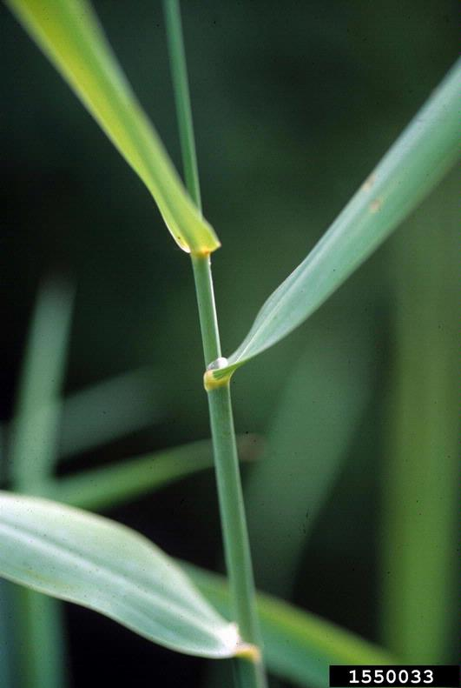
INTRODUCTION

Identification Tips
- Reed canarygrass is a perennial grass with stems that can grow to 6 feet tall.
- Leaves sprout horizontally from the main stem, and are thin, green, and coarse in texture.
- In late summer, reed canarygrass sets seed with a seed head that is gold, red or purplish in color.
- Reed canarygrass has creeping rhizomes and runners.

Impacts
- In Washington and Oregon, reed canarygrass is considered to be a serious threat to wetland ecosystems.
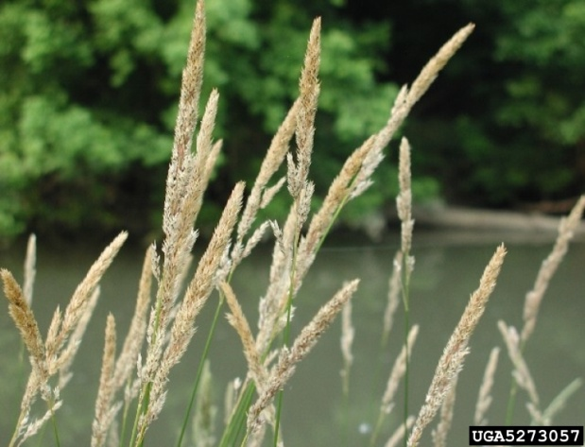
- Because of its capacity to form dense monocultures, reed canarygrass creates problems for native wildlife. Few species eat the grass, and the individual stalks grow too densely to provide nesting habitat or shelter for many birds and small mammals.

Habitat & Distribution
- Reed canarygrass grows best in moist sites such as wetlands and riverbanks.
- It can also be found in poorly-drained soils such as those near canals and streams.

Reproduction & Spread
- Reed canarygrass reproduces by seed, rhizomes, and runners.
- Creeping rhizomes can force out native species and form a dense monoculture.
- It can also produce roots and shoots from the culm (nodes or joints along the stem).

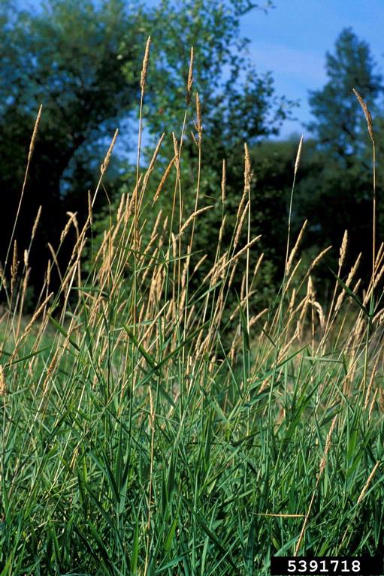
CONTROL INFORMATION

Integrated Pest Management
- The preferred approach for weed control is Integrated Pest Management (IPM). IPM involves selecting from a range of possible control methods to match the management requirements of each specific site. The goal is to maximize effective control and to minimize negative environmental, economic, and recreational impacts.
- Use a multifaceted and adaptive approach. Select control methods reflecting the available time, funding, and labor of the participants, the land use goals, and the values of the community and landowners. Management will require dedication for a number of years and should allow flexibility in methods.

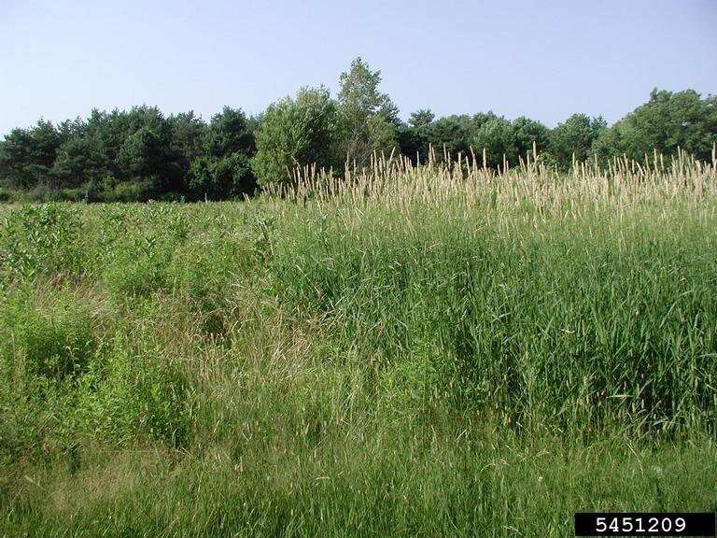
Planning Considerations
- Survey the area for weeds, set priorities, and select the best control method(s) for the site.
- Select control practices to minimize soil disturbance. Minimizing disturbance prevents further infestations of weeds.
- Begin work on the perimeter of infested areas first and move inward to the core of the infestation.
- Monitor the site and continue to treat plants that germinate from the seed bank.
- Revegetate the treatment areas to improve ecosystem function and prevent new infestations.

Early Detection and Prevention
- Minimize soil disturbance from vehicles, machinery, and over-grazing to reduce areas where weeds may become established.
- Reed canarygrass is easiest to identify in summer when the seed heads have formed. Conduct a site survey to determine treatment needs.
- Most infestations will require mechanical or chemical methods of control.
- Monitor and re-treat infestations as necessary. Ensure any existing plants do not produce and release seed.
- Thoroughly clean tools, boots, and vehicles after working in or traveling through an infested area to prevent the spread of noxious weeds.

Manual, Mechanical, & Cultural Control
- Use a string trimmer to cut reed canarygrass as close to the ground as possible.
- Keep your tools, vehicles, and clothing free from weed seeds to prevent spread.
- Combine tilling with a proper flooding regime to control reed canarygrass.
- Solarization, shading, and mulching have all been used to eliminate reed canarygrass.
- Plant fast-growing shrubs and trees to shade out reed canarygrass infestations.

Herbicide Control
- Apply herbicides at proper rates and for the site conditions or land usage specified on the label. Follow all label directions and wear recommended personal protective equipment (PPE).
- To control large infestations, herbicide use may be effective either alone or in combination with mowing. Treated areas should not be mowed until after the herbicide has taken effect and weeds are brown and dead.
- Monitor areas for missed and newly germinated plants.
- Choose selective herbicides over non-selective herbicides when applying in a grassy area.
- Minimize the impacts to bees and other pollinators by controlling weeds before they flower. When possible, make herbicide applications in the morning or evening when bees are least active. Avoid spraying pollinators directly.

Specific Herbicide Information
Herbicides are described here by the active ingredient. Many commercial formulations are available containing specific active ingredients. References to product names are for example only. Directions for use may vary between brands.
- Since reed canarygrass frequently grows in wet areas, only aquatic-approved herbicides are allowed in many situations. As with all herbicide use, be sure to read and follow all label instructions and to abide by all state regulations. Permits may be required to make herbicide applications in a wetland.
- Glyphosate (Rodeo) with a surfactant approved for use near water works well to kill reed canarygrass. Glyphosate is a non-selective herbicide that kills or injures most plant species.
- Combine herbicide treatment with another control method for good results. First, mow or burn to eliminate the dead leaf litter and allow the reed canarygrass to re-grow to 18-24 inches. This reduces herbicide use and increases coverage, since you are spraying only the reed canarygrass regrowth.
- Follow-up monitoring and treatment is necessary for several years to ensure complete kill.

  - This BMP does not constitute a formal recommendation. When using herbicides, always consult the label. Please refer to the Pacific Northwest Weed Management Handbook or contact your local weed authority.

Resources

http://columbiagorgecwma.org/weed-listing/best-management-practices/reed-canarygrass/

http://mdc.mo.gov/your-property/problem-plants-and-animals/invasive-plants/reed-canary-grass-control

http://tncweeds.ucdavis.edu/esadocs/phalarun.html

http://www.invasive.org/gist/moredocs/phaaru01.pdf

http://www.kingcounty.gov/environment/animals-and-plants/noxious-weeds/weed-control-practices/bmp.aspx

http://www.nrcs.usda.gov/Internet/FSE_DOCUMENTS/nrcs144p2_035064.pdf

http://www.nwcb.wa.gov

