shiny geranium

  - Geranium lucidum
Geranium Family
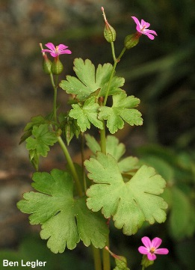

INTRODUCTION

Identification Tips

Shiny geranium is an herbaceous, low-growing winter annual or biennial.
- Round to kidney-shaped leaves are shiny green and sparsely covered in stiff hairs. Leaves are divided into 5-7 lobes and grow on red, hairless stems. Leaves become red and waxy at the end of the summer.
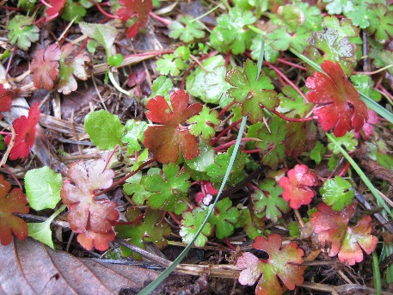
- Small, pink to purple flowers with five petals grow in pairs on little stems. Sepals around the base of the flower are keeled with noticeable cross-ribs and are a key identification trait. Flowers bloom spring to late July.
- The fruit has a long, straight, pointed beak. Small, oval seeds are hairless and reddish with a black projection.
- Shiny geranium resembles the common yard weed known as dovefoot geranium (Geranium molle). Dovefoot geranium’s petals are deeply notched and are very fuzzy. The sepals of dovefoot are smooth and fuzzy and the stems are less red than shiny geranium.

Impacts
- Though it appears delicate, shiny geranium is extremely resilient and aggressive. It establishes quickly and dominates a site by displacing native communities with a monoculture of weeds.
- Similar to another invasive geranium, herb Robert (Geranium robertianum), shiny geranium takes advantage of disturbed sites such as roadsides, but it is also adept at invading high quality native habitat in both forest understories and grasslands.

Habitat & Distribution
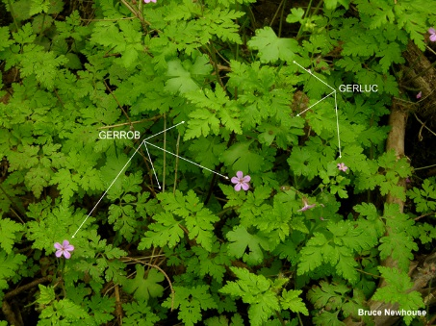
- Native to Europe and Asia, shiny geranium has invaded oak woodlands, riparian corridors, forest understories, roadsides, and pastures in the Pacific Northwest, primarily west of the Cascade Mountain Range.
- Likely introduced as an ornamental flower, shiny geranium has moved north through Oregon and is currently advancing up the Interstate 5 corridor in Washington as well as east through the Columbia Gorge.
- Shiny geranium has emerged as a contaminant in nursery stock in Oregon and Washington, so care should be taken when purchasing plants from infested areas.
G. robertianum vs. G. lucidum

Reproduction & Spread
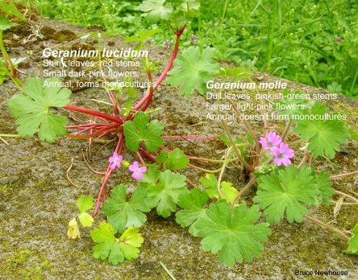
- Shiny geranium is shallow-rooted and spreads by a forcefully ejected seed, helping it spread up as well as out from parent plants.
- Plants emerge after the first fall rains and grow throughout the winter and early spring.
- Flowering occurs from April to July and when conditions are favorable, multiple generations per year are possible.
- Seeds can remain viable in the soil for several years.

CONTROL INFORMATION
G. lucidum vs. G. molle

Integrated Pest Management
- The recommended approach for weed control is Integrated Pest Management (IPM). IPM involves selecting from a broad range of control methods to strengthen the impact of management practices given the ecology of the pest and the specific site conditions where it occurs. The goal of IPM is to maximize effective control and to minimize negative environmental, economic, and recreational impacts.
- Use a multifaceted and adaptive approach. Select control methods reflecting the available time, funding, and labor of the participants, the land use goals, and the values of the community and landowners. Management will require dedication for a number of years and should allow flexibility in methods.

Planning Considerations
- Survey area for weeds, set priorities, and select the best control method(s) for the site.
- Control practices should be selected to minimize soil disturbance. Minimizing disturbance prevents further infestations of weeds.
- Begin work on the perimeter of the infested area first and move inward toward the core of the infestation.
- Monitor the site and continue to treat plants that germinate from the seed bank, multiple times a year for several years.
- Revegetate the treatment areas to improve ecosystem function and prevent new infestations.

Early Detection and Prevention
- Shiny geranium is identifiable in late fall through July, depending on moisture.
- Control new infestations as early as possible and up to four times a year to ensure no plants set seed.
- Minimize soil disturbance from vehicles, machinery, and over-grazing to reduce seed germination.
- Monitor for new plants and re-treat as necessary. Ensure any existing plants do not produce and release seed.
- Prevent the additional spread of invasive weeds by thoroughly cleaning tools, boots, and vehicles after working in or traveling through an infested area.

Manual, Mechanical, & Cultural Control
- Hand pull shiny geranium by grasping the center of the plant close to the ground, removing as much of the root system as possible. Re-sprouting is possible from root fragments. Bag and dispose of plants in the garbage, not the compost.
- If plants are in seed, mowing will increase the rate of spread and will likely create new infestations elsewhere. Mowing or string trimming is not recommended.
- Covering shiny geranium with black plastic may provide good control for small infestations if the covering is maintained for several growing seasons.

Herbicide Control
- Only apply herbicides at proper rates and for the site conditions or land usage specified on the label. Follow all label directions and wear recommended personal protective equipment (PPE).
- Some herbicides may require the addition of an approved surfactant. Follow the label direction for selecting the correct type of surfactant and ensure both surfactant and herbicide are labeled for aquatic use if working near water.
- Monitor treated areas for missed and newly germinated plants. Selective herbicides are preferred over non-selective herbicides when applying in a grassy area.
- Minimize impacts to bees and other pollinators by controlling weeds before they flower. If possible, make herbicide applications in the morning or evening when bees are least active. Avoid spraying pollinators directly.

Specific Herbicide Information
Herbicides are described here by the active ingredient. Many commercial formulations are available containing specific active ingredients. References to product names are for example only. Directions for use may vary between brands.

Spray shiny geranium after plants have emerged, but before flowering which typically begins in March. Late fall when plants have germinated after summer dormancy is also a good time to use an herbicide.
- Glyphosate (e.g., AquaNeat or Round-Up) – Non-selective, will kill grasses and other monocots. At a rate of 1-2%, glyphosate sprayed in the fall or in early spring has a high percentage of control.
- Continuously monitor for new plants, especially following any disturbance to the soil such as tilling or construction. Retreat as necessary, sometimes up to four times a year. Do not allow any plants to set seed.

Contractors/Licensed Applicators
- Glufosinate ammonium (e.g. Reckon or Finale) sprayed in November kills target plants with no spring growth.
- Glyphosate + Scythe (1% of each) in October kills target plants with no spring growth.
- Imazapyr (e.g., Arsenal or Habitat) at 16 oz/acre in October

  - This BMP does not constitute a formal recommendation. When using herbicides, always consult the label. Please refer to the Pacific Northwest Weed Management Handbook or contact your local weed authority.

Additional Resources

http://columbiagorgecwma.org/weed-listing/best-management-practices/shinygeranium/

https://catalog.data.gov/dataset/ridgefield-shiny-geranium-survey-and-control/resource/3144d335-d972-4b8b-bb27-1d8ddf3e71c9

http://hortsense.cahnrs.wsu.edu/Home/HortsenseHome.aspx

https://pnwhandbooks.org/weed/problem-weeds/geranium-shiny-geranium-lucidum-herb-robert-geranium-robertianum

https://www.clark.wa.gov/sites/default/files/dept/files/public-works/Vegetation/shiny-geranium_pw_7-6-16.pdf

http://www.kingcounty.gov/environment/animals-and-plants/noxious-weeds/weed-control-practices/bmp.aspx

http://www.nwcb.wa.gov

