spotted knapweed

  - Centaurea stoebe
Sunflower Family

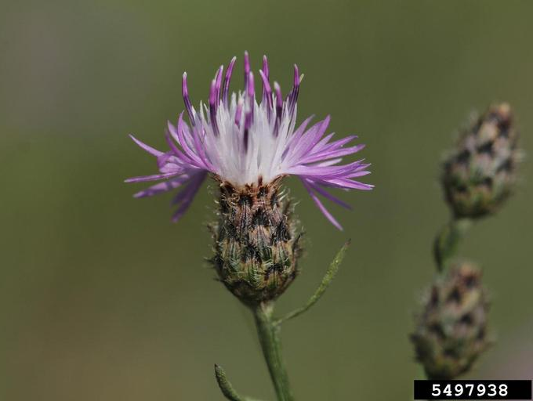
INTRODUCTION

Identification Tips

Spotted knapweed is a biennial or perennial forb, growing 2-5 feet tall with a stout taproot.
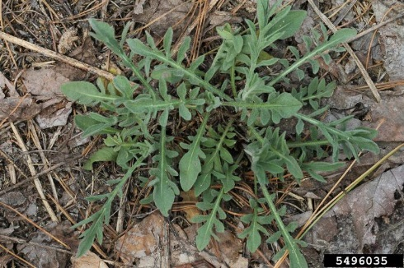
- A rosette of deeply lobed, blue-gray leaves forms in the first year before branched stems flower in the second year.
- Stem leaves are divided into lobes but become smaller up the stem and less lobed until the upper leaves are linear and entire.
- Heads of pink to purple, sometimes white, flowers are borne at the ends of the branches. Urn-shaped heads are ¼ inch in diameter and ½ inch tall, excluding flowers.
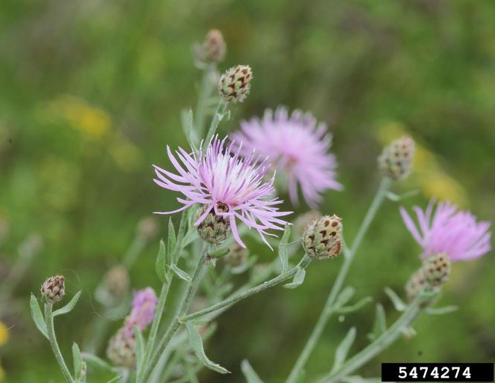
- Bracts at the base of the head are egg-shaped with black veins and a brown/black triangular tip with a comb-like fringe along its edge. The dark tip color gives the flower head base a spotted look. White flowered plants often lack the dark spot on the bract tip.
- Flowers June to October.

Impacts
- Knapweed plants contain known carcinogenic compounds.
- Also, plants exude allelopathic compounds from the roots which inhibit the growth of other plants, creating patches of weeds with few other native species.
Photos by: Rob Routledge, Sault College, Bugwood.org

- Knapweed degrades pastures and rangeland, minimizing valuable forage to livestock and wildlife.
- It also reduces the water storage of soil and increases erosion.

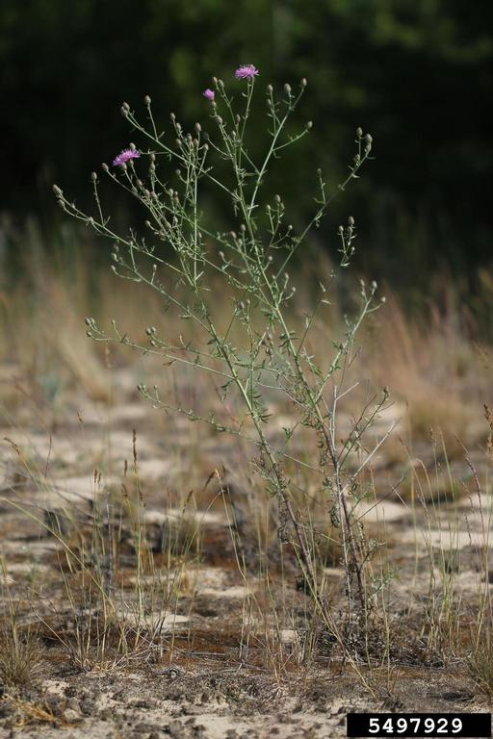
Habitat & Distribution
- Spotted knapweed is found in dry meadows, pastures, rocky areas, open ground, travel corridors, hayfields, forest clearings, and on the sandy or gravelly floodplains of streams and rivers.
- It is currently distributed throughout the Pacific Northwest.

Reproduction & Spread
- Spotted knapweed seeds have short bristles (pappus) on one end and spread primarily by wind, water and from being transported via animals or vehicles.
- Spotted knapweed reproduces by seeds with plants producing from 1,000 – 25,000 seeds per plant.
- Seeds may be viable for up to 8 years.

CONTROL INFORMATION

Integrated Pest Management
- The recommended approach for weed control is Integrated Pest Management (IPM). IPM involves selecting from a broad range of control methods to strengthen the impact of management practices given the ecology of the pest and the specific site conditions where it occurs. The goal of IPM is to maximize effective control and to minimize negative environmental, economic, and recreational impacts.
- Use a multifaceted and adaptive approach. Select control methods reflecting the available time, funding, and labor of the participants, the land use goals, and the values of the community and landowners. Management will require dedication for a number of years and should allow flexibility in methods.

Planning Considerations
- Survey area for weeds, set priorities, and select the best control method(s) for the site.
- Control practices should be selected to minimize soil disturbance. Minimizing disturbance prevents further infestations of weeds.
- Begin work on the perimeter of the infested area first and move inward toward the core of the infestation.
- Monitor the site and continue to treat plants that germinate from the seed bank.
- Revegetate the treatment areas to improve ecosystem function and prevent new infestations.

Early Detection and Prevention
- Knapweed is identifiable most the year.
- Control new infestations as early as possible.
- Minimize soil disturbance from vehicles, machinery, and over-grazing to reduce seed germination.
- Monitor for new plants and re-treat as necessary. Ensure any existing plants do not produce and release seed.
- Prevent the additional spread of invasive weeds by thoroughly cleaning tools, boots, and vehicles after working in or traveling through an infested area.

Manual, Mechanical, & Cultural Control
- Handpulling rosettes or upright plants can be effective for small infestations. Wearing gloves and long-sleeved shirts is highly recommended and a shovel may be needed in dry, hard-packed soil. Remove as much of the roots as possible.
- Mowing should occur after most of the flowering has ended (flower is open less than 10 days), but BEFORE seeds have matured. At this time there is not usually enough moisture available for the plants to regrow. Note: mowing alone will not kill knapweed.
- Tilling and cultivation that buries seeds and plant matter below a depth of 1½ inches can be effective, especially if the area is replanted with a healthy cover crop.

Biological Control
Non-native plants easily establish large infestations and become widespread in their introduced range because they have no natural enemies as they do in their native range. Biological control deliberately reunites a species with its natural enemies, including insects and pathogens, in hopes of achieving the balance found in the plant’s native range. Biological control is not available for all species and will only reduce seed production or the size of the infestation, not eradicate it. It is generally most effective when used in conjunction with other control techniques.
- Two seed-head feeding weevils, Larinus obtusus and L. minutus, are distributed throughout the Pacific Northwest and are available for local distribution. These two agents decrease seed production for spotted knapweed, as well as diffuse and meadow knapweeds. Mowing, nor spraying, is compatible with these agents.
- Cyphocleonus achates, a root-feeding weevil, attacks spotted and diffuse knapweeds, but is not widely available. This weevil can kill small plants and decrease biomass and density of larger plants. Mowing may be compatible with this agent.

Herbicide Control
- Only apply herbicides at proper rates and for the site conditions or land usage specified on the label. Follow all label directions and wear recommended personal protective equipment (PPE).
- For control of large infestations, herbicide use may be effective either alone or in combination with mowing. Treated areas should not be mowed until after the herbicide has taken effect and weeds are brown and dead.
- Monitor treated areas for missed and newly germinated plants. Selective herbicides are preferred over non-selective herbicides when applying in a grassy area.
- Minimize impacts to bees and other pollinators by controlling weeds before they flower. If possible, make herbicide applications in the morning or evening when bees are least active. Avoid spraying pollinators directly.

Specific Herbicide Information
Herbicides are described here by the active ingredient. Many commercial formulations are available containing specific active ingredients. References to product names are for example only. Directions for use may vary between brands.

Recommendations for control of spotted knapweed:
- Spot treat with glyphosate (e.g., Round-Up) at 2% to actively growing plants
- Apply aminopyralid (e.g., Milestone) at a rate of 4-7 fl oz/acre to actively growing plants in fall or spring, from rosette to bolting growth stages.
- Continuously monitor for new plants, especially following any disturbance to the soil such as tilling or construction. Plants often regrow, so annual applications may be necessary for several years.
- Read and follow the label. It may be necessary to include a surfactant to your mix.

Contractors/Licensed Applicators
- Aminopyralid (e.g., Milestone) at 5-7 oz/acre + a non-ionic surfactant.
- Clopyralid (e.g., Transline) at 1-1 1/3 pints/acre + a non-ionic surfactant.
- Consult the label for effective timing and follow-up with additional treatments for the most effective control.

  - This BMP does not constitute a formal recommendation. When using herbicides, always consult the label. Please refer to the Pacific Northwest Weed Management Handbook or contact your local weed authority.

Additional Resources
http://columbiagorgecwma.org/weed-listing/best-management-practices/spottedknapweed/

http://hortsense.cahnrs.wsu.edu/Home/HortsenseHome.aspx

https://pnwhandbooks.org/weed/problem-weeds/knapweeds-centaurea-spp-acroptilon-repens

https://your.kingcounty.gov/dnrp/library/water-and-land/weeds/Brochures/Spotted_Knapweed_factsheet.pdf

https://www.co.lincoln.wa.us/weedboard/wp-content/uploads/sites/4/2016/04/SPOTTED-KNAPWEED-BROCHURE.pdf

https://www.nwcb.wa.gov/weeds/spotted-knapweed

