Ventenata or wiregrass

  - Ventenata dubia
Grass Family
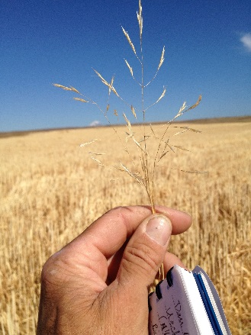

INTRODUCTION

Identification Tips

Ventenata is a winter annual grass, germinating in the fall.
- Stems are slim and erect, from 4-18 inches tall, with microscopic hairs that make it look smooth.
- Seed heads are produced May through June when it is identifiable by its reddish-black nodes.
- The inflorescence, or flowerhead, is a silvery-green open panicle before it quickly matures to a yellowish-tan color.
- At the end of a droopy seed stalk (rachilla), 1-5 spikelets occur. Approximately 15 - 35 seeds per plant are produced.
- When ventenata senesces in late summer, the awns become twisted and bent.

Look-a-likes

Ventenata can look very similar to the native tufted hairgrass (Deschampsia cespitosa). Ventenata generally has purple to reddish brown culm nodes. When flowering are present the upper awns of Ventenata are sharply bent, while the awn of the first floret is not bent. The rachilla of D. cespitosa is hairy, whereas they are generally glabrous on ventenata.

Impacts
- Ventenata is mostly unpalatable and there is little to no forage value once stems harden.
- A shallow root system can contribute to erosion.
Illustration by Linda Ann Vorobik and Hana Pazdirkova © Utah State University, used with permission.
- Productivity and value decreases over time in areas where ventenata infestations occur.

Habitat & Distribution
- Ventenata is native to southern Europe, western Asia, and northern Africa. It is primarily found on the east side of the Cascade Mountain Range, but is increasingly found west of the Cascades.
- It has invaded hay fields, pastures, and rangelands in the Pacific Northwest as well as disturbed sites, roadsides, and restoration areas.

Reproduction & Spread
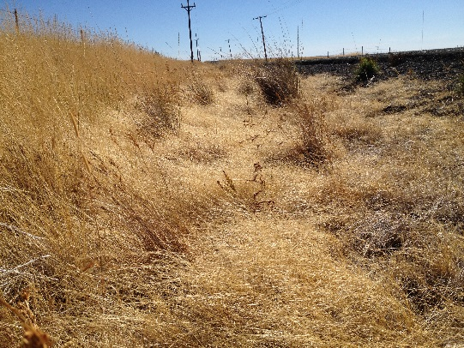
- Ventenata is an annual grass and spreads by seed.
- For most sites, seedling emergence occurs when fall rains have increased the moisture in the soil. In Timothy hay and rangeland habitats, germination typically occurs in the spring when environmental conditions are more favorable.
- Because of higher moisture levels in the soil, germination and seedling survival is higher when there is a higher ventenata litter layer versus a bare surface during drier or colder fall seasons. ¹
- Less than 1% of the seed bank may remain viable for up to 3 years at shallow soil. ¹

CONTROL INFORMATION

Integrated Pest Management
- The recommended approach for weed control is Integrated Pest Management (IPM). IPM involves selecting from a broad range of control methods to match the management requirements of each specific site. The goal is to maximize effective control and to minimize negative environmental, economic, and recreational impacts.
- Use a multifaceted and adaptive approach. Select control methods reflecting the available time, funding, and labor of the participants, the land use goals, and the values of the community and landowners. Management may require dedication for several years and should allow flexibility in methods.

Planning Considerations
- Survey area for weeds, set priorities, and select the best control method(s) for the site.
- Control practices should be selected to minimize soil disturbance. Minimizing disturbance prevents further infestations of weeds.
- Begin work on the perimeter of the infested area first and move inward toward the core of the infestation.
- Monitor the site and continue to treat plants that germinate from the seed bank.
- Revegetate the treatment areas to improve ecosystem function and prevent new infestations.

Early Detection and Prevention
- Control new infestations as early as possible.
- Minimize soil disturbance from vehicles, machinery, and over-grazing to reduce seed germination.
- Monitor for new plants and re-treat as necessary. Ensure any existing plants do not produce and release seed.
- Prevent the additional spread by thoroughly cleaning tools, boots, and vehicles after working in or traveling through an infested area.

Manual, Mechanical, & Cultural Control
- Mowing multiple times during the season may provide some control and could even prevent seed production.
- Prescribed burning during the fall could “eliminate the benefits of litter on seedling recruitment.” ¹ Follow-up with a seeding of desirable grasses to increase competition in the newly formed open area.
- In a perennial grass system, spring Nitrogen fertilizer applications timed during growth of the desired perennial grasses can result in a decrease of V. dubia and “significant increases in perennial grasses.
- Any control strategies should be practiced for at least 3 years to exhaust the seed bank.

Herbicide Control
- Only apply herbicides at proper rates and for the site conditions or land usage specified on the label. Follow all label directions and wear recommended personal protective equipment (PPE).
- For control of large infestations, herbicide use may be effective either alone or in combination with mowing. Treated areas should not be mowed until after the herbicide has taken effect and weeds are brown and dead.
- Monitor treated areas for missed and newly germinated plants.
- Minimize impacts to bees and other pollinators. If possible, make herbicide applications in the morning or evening when bees are least active. Avoid spraying pollinators directly.

Specific Herbicide Information
Herbicides are described here by the active ingredient. Many commercial formulations are available containing specific active ingredients. References to product names are for example (Ex.) only. Directions for use may vary between brands.
- For large infestations, a combination of mowing and then treating the regrowth may be the best option. Follow-up as necessary.
- Continuously monitor for new plants, especially following any disturbance to the soil such as tilling or construction.
- A field study² found Rimsulfuron (Ex. Matrix DG) or Flufenacet plus metribuzin (Ex. Axiom DF) provided the most consistent control (>90%) when applied during the pre-emergent time period.
- For early post-emergence treatments, the study found Rimsulfuron (Ex. Matrix DG) or Sulfosulfuron (Ex. Outrider) had 90% control.
- Aminopyralid applied at seedling stage reduced seed production ~95-99%.

Additional Notes
- Rimsulfuron has a grazing restriction, but was found to be safer on perennial grasses.
- Sulfosulfuron can be used in grass hay, but may injure smooth brome and timothy.
- Flufenacet plus metribuzin provided control without injury to timothy.
- Fertilizer additions previously described may be combined with an herbicide treatment to enhance management.

  - This BMP does not constitute a formal recommendation. When using herbicides, always consult the label. Please refer to the Pacific Northwest Weed Management Handbook or contact your local weed authority.

Additional Resources

https://www.cabi.org/isc/datasheet/117772

http://columbiagorgecwma.org/weed-listing/best-management-practices/ventenata/

http://hortsense.cahnrs.wsu.edu/Home/HortsenseHome.aspx

https://plants.usda.gov/plantguide/pdf/pg_vedu.pdf

https://pnwhandbooks.org/weed/problem-weeds/wiregrass-african-ventenata-ventenata-dubia

http://wric.ucdavis.edu/information/natural%20areas/wr_V/Ventenata.pdf

https://www.nwcb.wa.gov/images/weeds/Ventenata_dubia_written_findings_final.pdf

Wallace, J., Pavek, P., & Prather, T. (2015). Ecological Characteristics of Ventenata dubia in the Intermountain Pacific Northwest. Invasive Plant Science and Management, 8(1), 57-71. doi:10.1614/IPSM-D-14-00034.1
Wallace, J., & Prather, T. (2016). Herbicide Control Strategies for Ventenata dubia in the Intermountain Pacific Northwest. Invasive Plant Science and Management, 9(2), 128-137. doi:10.1614/IPSM-D-16-00017.1
Rinella, M.J., Bellows, S.E., Roth, A.D. 2014. Aminopyralid constrains seed production of the invasive annual grasses medusahead and ventenata. Rangeland Ecology and Management. 67:406-411.

