yellow starthistle

  - Centaurea solstitialis
Sunflower Family
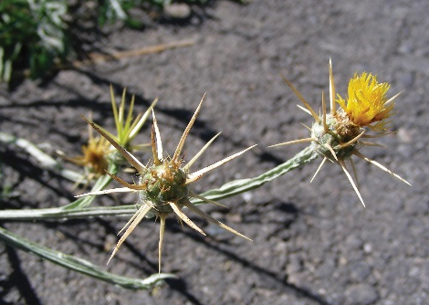

INTRODUCTION

Identification Tips

Yellow starthistle is a winter annual or biennial forb, growing between 1 and 3 feet tall.
- As seedlings, yellow starthistle forms a basal rosette with deeply lobed leaves that resemble a dandelion. Alternating upper leaves are narrow and undivided.
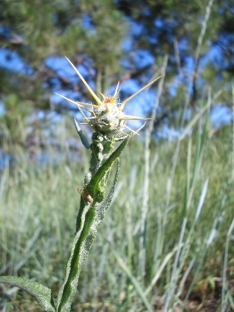
- Rigid, winged stems are extensively branched and like the leaves, are covered in wooly hairs, giving it a dull, green to gray tinge.
- Yellow, knapweed-like flowers with sharp spines bloom from July to August.

Impacts
- Yellow starthistle aggressively invades rangelands and pastures and a long tap root allows it to quickly outcompete native vegetation and desirable forage for livestock and wildlife.
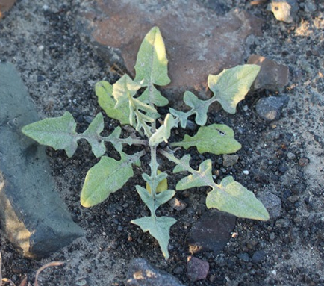
- It is toxic to equine and cattle and can cause physical injury to smaller livestock such as sheep.
- Toxins in yellow starthistle cause “chewing disease” in horses, which is often fatal.

Habitat & Distribution
- Yellow starthistle thrives in grasslands, rangelands, pastures, roadsides, railways, and other disturbed sites.
- It prefers semi-arid regions and is primarily found on the east side of the Cascade Mountain Range in the Pacific Northwest.

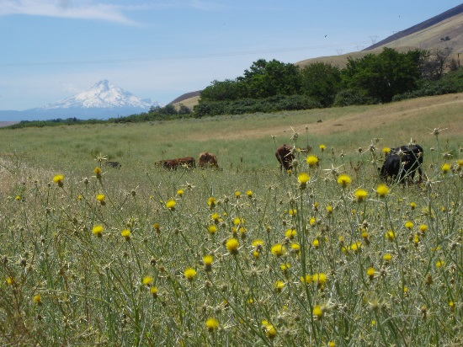
Reproduction & Spread
- Yellow starthistle reproduces by seed that germinates in the fall.
- Each plant can produce up to 150,000 seeds that are then transported by wind, vehicles, and other human activities.
- Yellow starthistle has also been identified as a contaminant in seed, alfalfa, clover, hay, and straw.
- Seeds can remain viable in the soil for several years.

CONTROL INFORMATION

Integrated Pest Management
- The recommended approach for weed control is Integrated Pest Management (IPM). IPM involves selecting from a broad range of control methods to strengthen the impact of management practices given the ecology of the pest and the specific site conditions where it occurs. The goal of IPM is to maximize effective control and to minimize negative environmental, economic, and recreational impacts.
- Use a multifaceted and adaptive approach. Select control methods reflecting the available time, funding, and labor of the participants, the land use goals, and the values of the community and landowners. Management will require dedication for a number of years and should allow flexibility in methods.

Planning Considerations
- Survey area for weeds, set priorities, and select the best control method(s) for the site.
- Control practices should be selected to minimize soil disturbance. Minimizing disturbance prevents further infestations of weeds.
- Begin work on the perimeter of the infested area first and move inward toward the core of the infestation.
- Monitor the site and continue to treat plants that germinate from the seed bank.
- Revegetate the treatment areas to improve ecosystem function and prevent new infestations.

Early Detection and Prevention
- Yellow starthistle seeds germinate in the fall and are visible throughout the winter before bolting in the spring.
- Control new infestations as early as possible.
- Minimize soil disturbance from vehicles, machinery, and over-grazing to reduce seed germination.
- Monitor for new plants and re-treat as necessary. Ensure any existing plants do not produce and release seed.
- Prevent the additional spread of invasive species by thoroughly cleaning tools, boots, and vehicles after working in or traveling through an infested area.

Manual, Mechanical, & Cultural Control
- With small infestations, hand pulling can effectively control yellow starthistle. At bolting or pre-flower stage, pull plants and ensure no stem material remains above ground. If flowers are present or seeds are developing, bag plant material and dispose of it in the garbage.
- Mowing can be an effective management tool; however, timing is crucial. Mowing is most effective during the early flowering stage or when most buds have produced spines. However, success only occurs when no leaves are present below the cut level. Mowing too early can result in higher seed production and mowing after seed set typically increases the infestation. Note: mowing can decrease reproduction of insect biocontrol agents, can injure late season native forbs, and reduces fall and winter forage for livestock and wildlife.
- Any manual or mechanical control methods should be repeated throughout the growing season, every 2-4 weeks, with a goal of avoiding seed set and depleting the seed bank.
- Yellow starthistle favors disturbed sites and overgrazed pastures and range. To help prevent infestation, maintain a healthy, competitive vegetative stand and avoid disturbing the soil.
- During the time when yellow starthistle is bolting or just before flowering, high-intensity, short-duration grazing by sheep, goats, or cattle can be an effective control method. Grazing alone will not be sufficient but can be used in an integrated pest management program. Note: yellow starthistle is toxic to horses.

Biological Control

Non-native plants easily establish large infestations and become widespread in their introduced range because they have no natural enemies as they do in their native range. Biological control deliberately reunites a species with its natural enemies, including insects and pathogens, in hopes of achieving the balance found in the plant’s native range. Biological control is not available for all species and will only reduce seed production or the size of the infestation, not eradicate it. It is generally most effective when used in conjunction with other control techniques.
- The primary agent in the Pacific Northwest is Eustenopus villosus, a seed-feeding weevil. Larvae of this weevil consume 90-100% of seeds.
- There are several secondary agents available in the PNW, including Larinus curtus, Bangasternus orientalis, and Chaetorellia australis, also seed-feeding insects.
- These agents have varying successes but can be a valuable component in an integrated pest management program. Contact your local weed authority for more information.

Herbicide Control
- Only apply herbicides at proper rates and for the site conditions or land usage specified on the label. Follow all label directions and wear recommended personal protective equipment (PPE).
- For control of large infestations, herbicide use may be effective either alone or in combination with mowing. Treated areas should not be mowed until after the herbicide has taken effect and weeds are brown and dead.
- Monitor treated areas for missed and newly germinated plants. Selective herbicides are preferred over non-selective herbicides when applying in a grassy area.
- Minimize impacts to bees and other pollinators by controlling weeds before they flower. If possible, make herbicide applications in the morning or evening when bees are least active. Avoid spraying pollinators directly.

Specific Herbicide Information
Herbicides are described here by the active ingredient. Many commercial formulations are available containing specific active ingredients. References to product names are for example only. Directions for use may vary between brands.

- Aminopyralid (e.g., Milestone) applied to seedlings or rosette stage at 3 oz/acre or to larger plants at 5 oz/acre is one of the most effective herbicides for yellow starthistle control.
- Clopyralid (e.g., Transline) applied to seedlings or rosettes at .25 pints/acre or to larger, bolted plants at .67 pints/acre.
- Glyphosate (e.g., Roundup) is most effective for late season control when applied to actively growing plants at a rate of 2% solution for spot treatment. Note: glyphosate is non-selective and will injure or kill grasses.
- If not already mixed in a solution, use a non-ionic surfactant (e.g., Li 700) to increase effectiveness.
- Continuously monitor for new or missed plants, especially following any disturbance to the soil such as tilling or construction, and retreat as necessary.

Contractors/Licensed Applicators
- 5 oz/acre aminopyralid (e.g., Milestone) plus a non-ionic surfactant (e.g., Li 700)
- 16 oz/acre picloram (e.g., Tordon 22k) plus a non-ionic surfactant. Note: Tordon 22k is a federally restricted-use pesticide and may not be registered for use in all areas.

  - This BMP does not constitute a formal recommendation. When using herbicides, always consult the label. Please refer to the Pacific Northwest Weed Management Handbook or contact your local weed authority.

Additional Resources

http://columbiagorgecwma.org/weed-listing/best-management-practices/yellowstarthistle/

http://hortsense.cahnrs.wsu.edu/Home/HortsenseHome.aspx

https://pnwhandbooks.org/weed/problem-weeds/starthistle-yellow-centaurea-solstitialis-purple-centaurea-calcitrapa-iberian

http://www.nwcb.wa.gov

http://wric.ucdavis.edu/information/natural%20areas/wr_C/Centaurea_solstitialis.pdf

