Tree of Heaven

  - Ailanthus altissima
Simaroubaceae Family

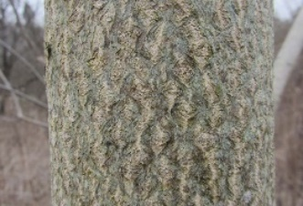
INTRODUCTION

Identification Tips
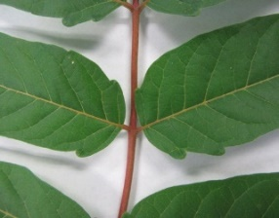
- Tree of heaven is an introduced deciduous tree species growing up to 80 feet tall and six feet in diameter. It produces a long tap root and suckers freely when cut, making it difficult to control. Creeping roots may extend out to 50 feet in all directions.
The bark develops shallow, diamond-shaped fissures resembling a cantaloupe.
- When crushed, plant parts have a distinct, peanut-butter or popcorn odor.
- The bark on young trees is smooth and green. As it ages, the bark turns gray and develops shallow, diamond-shaped fissures.
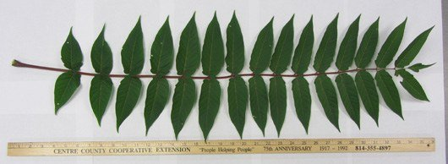
- Leaves are pinnately compound, meaning they have leaflets attached on each side of a central stem. Leaflets have mostly smooth edges with one to two protruding bumps at the base called glandular teeth.
Glandular teeth at the base of the leaflet.
- Greenish to brown twigs grow alternately on the tree and lack a terminal bud.
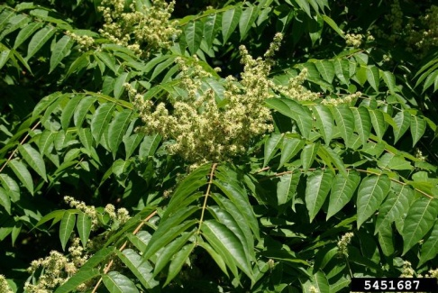
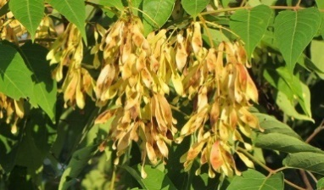
- Male and female flowers form in terminal clusters on separate trees. Flower clusters may be up to 12 inches wide and are largest on male trees. Tiny individual flowers are light green to pale.
10-40 leaflets can occur on one leaf.
- In late summer through autumn, tree of heaven produces large clusters of papery wings (samaras), each with a single central seed. The samaras vary from greenish-yellow to red-brown and are often vibrantly colored in the fall.
Clusters of papery wings, or samaras, include a single, central seed.
Photo by Leslie J. Mehroff, University of Connecticut
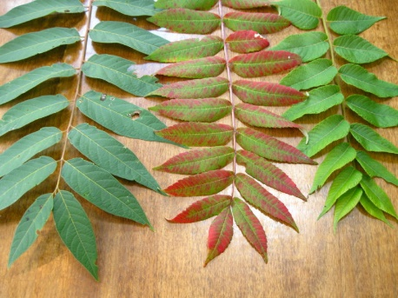
Tree of Heaven can be easily confused with other trees that have compound leaves with many leaflets, such as sumac or walnut. The leaf edges of the look-alikes typically have teeth or serrations, while those of tree of heaven are smooth.
- Other identifying features include v-shaped leaf scars and a spongy, brown center inside twigs.

Impacts
Tree of heaven (left), smooth sumac (center), & black walnut (right). Photo by K. Guenther, http://wildfoods4wildlife.com
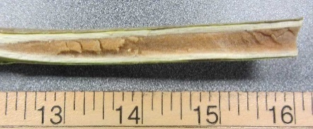
- Due to its rapid growth and structural weakness, tree of heaven is considered a tree-fall hazard. Its roots damage pavement, roads, and building foundations in urban areas.
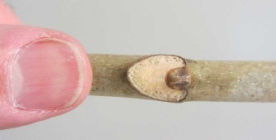
- Tree of heaven produces allelopathic chemicals in its leaves, roots, and bark. These are chemicals that affect the germination, growth, survival, and reproduction of other plants.
Easily broken twigs expose a large, spongy brown center.
- Ailanthus forms dense thickets, reducing wildlife habitat, particularly in riparian areas.
- It is a favorite host for the spotted lanternfly, an invasive and agriculturally damaging pest. See resources below.
V-shaped leaf scars can be seen on twigs.
- Tree of heaven can also be toxic. See caution label below.

Habitat & Distribution
- Tree of heaven grows in a variety of habitats and is commonly found in disturbed areas along forest edges, roadsides, fence rows, urban parks, old fields, and railroad embankments.
- It is tolerant of full sun to part shade, many types of pollution, and poor soil conditions.
- It can grow in many harsh environments, including pavement cracks!

Reproduction & Spread
- This weed reproduces both by seed and vegetatively by roots and stump sprouts. New shoots can sprout as far as 50 feet away from the parent tree.
- One tree can produce over 300,000 seeds annually, which are then dispersed by wind and birds.
- Cut stems can form roots when left on moist ground.

CONTROL INFORMATION

Integrated Pest Management
- The preferred approach for weed control is Integrated Pest Management (IPM). IPM involves selecting from a range of possible control methods to match the management requirements of each specific site. The goal is to maximize effective control and to minimize negative environmental, economic, and recreational impacts.
- Use a multifaceted and adaptive approach. Select control methods reflecting the available time, funding, and labor of the participants, the land use goals, and the values of the community and landowners. Management will require dedication for a number of years and should allow flexibility in methods.

Planning Considerations
- Survey area for weeds, set priorities, and select the best control method(s) for the site.
- Control practices should be selected to minimize soil disturbance. Minimizing disturbance avoids creating more opportunities for weed seed germination.
- Begin work on the perimeter of the infested areas first and move inward toward the core of the infestation.
- Monitor the site and continue to treat plants that germinate from the seed bank.
- Re-vegetate treatment areas to improve ecosystem function and prevent new infestations.

Early Detection and Prevention
- Small seedlings can be pulled in moist soil. Larger infestations will require the use of an appropriate herbicide.
- Dispose of cut material properly. Stem pieces can root in moist soil, so composting is not advised. Burn cut material if burning is allowed in your area. Otherwise, dispose of material in the landfill.
- Monitor and re-treat infestations as necessary. Ensure any existing plants do not produce and release seed by pulling small plants or treating with an herbicide in late July or August, prior to seed set.
- Prevent the spread of invasive plants by thoroughly cleaning tools, boots, and vehicles after working in or traveling through an infested area.

Manual, Mechanical, & Cultural Control
- Seedlings or small plants may be removed by hand, but once a strong root system has developed, other control methods will be required. Any root fragments left in the soil can sprout, forming new shoots. Revisit the site often to ensure complete control.
- Cutting or mowing tree of heaven is ineffective and should be avoided.
- A heavily shaded environment will reduce the establishment of tree of heaven.
- Avoid soil disturbance and re-vegetate disturbed areas to prevent further infestations.
- Simply cutting Tree of heaven will not control it. A “hack and squirt” herbicide treatment (see below) will need to be utilized to control suckering and continued growth.

Biological Control
- There are no biological agents available at this time.

Herbicide Control
- Only apply herbicides at proper rates and for the site conditions or land usage specified on the label. Follow all label directions and wear recommended personal protective equipment (PPE).
- Proper treatment timing and follow up the second year are critical for successful control.
- Target the roots with systemic herbicides applied in mid- to late summer when the tree is moving sugars to the roots. (If applied earlier, treatments may only injure above ground growth and not affect the root system.)
- Continue to monitor treatment sites for missed and newly-germinated seeds or regrowth. Seeds have a short dormancy and low seed-bank viability, so you should see germination rates decline quickly after the first treatment year if the seed source has been removed.
- Selective herbicides are preferred over non-selective herbicides when applying in a grassy area.
- Minimize impacts to bees and other pollinators by controlling weeds before they flower. If possible, make herbicide applications in the morning or evening when bees are least active. Avoid spraying pollinators directly.

Specific Herbicide Information
Herbicides are described here by the active ingredient. Many commercial formulations are available containing a specific active ingredient. References to product names are for example only. Directions for use may vary between brands.
Herbicides applied to foliage, bark, or frill cuts on the trunk are effective control measures. Cut stump treatments encourage root suckering and should not be utilized. Treatments should occur no earlier than July 1 and can continue up until the tree begins to show fall color. Effective herbicides include glyphosate, triclopyr, imazapyr, dicamba, and metsulfuron methyl.
- Use glyphosate (Roundup) plus triclopyr (Vastlan) as a foliar application (meaning directly to the leaves) where tree height and distribution allow effective coverage without unacceptable contact with desirable plants nearby. Apply treatment in mid- to late growing season, which is typically late July to August.
- Use a concentrated herbicide (triclopyr or glyphosate) solution in a frill (a.k.a. hack and squirt) application in mid- to late summer. Space cuts around the circumference of the tree, leaving uncut tissue so the herbicide moves to the roots. Apply a concentrated solution immediately to each of the cuts. Use either product undiluted or 1:1 with water.
- For dense infestations, treat initially with a foliar application to eliminate low growing stems or trees. Follow up with a frill application to larger trees not controlled earlier.

Contractors/Licensed Applicators
- For small infestations with trees up to six inches in diameter, use triclopyr ester (Garlon 4) at a rate of 20% in basal oil or Pathfinder II (ready to use) in a basal bark application (meaning directly to the bark) with a low-volume backpack sprayer. Wet the entire circumference of the lower 12-18 inches without runoff. For smaller diameter stems, use a shorter band. For larger than six-inch diameter, use a frill application (see above).
- For large infestations, use a high-volume sprayer initially to make a foliar application using glyphosate (3 quarts/acre) plus triclopyr (2 quarts/acre of Garlon 3A or 1.5 quarts/acre of Vastlan). Follow up with a basal bark or frill application.

Follow-up
- Monitoring and follow-up control will be necessary for several years after initial treatment.
- Note: Some herbicides persist in the soil, so please check the label before replanting.
- Tree of heaven is a host to the spotted lanternfly. To prevent pest movement in cut material, chip, compost, or burn (when safe to do so) material on site.

Caution
Tree of heaven has been known to cause skin irritations or allergies in some people. Additionally, there have been rare reports of myocarditis (inflammation of the heart muscle) from exposure to sap through broken skin. People who work around the tree should wear personal protective equipment, including eyewear and gloves.

  - This BMP does not constitute a formal recommendation. When using herbicides, always consult the label. Please refer to the Pacific Northwest Weed Management Handbook or contact your local weed authority.

Except where otherwise noted, all photos taken by David Jackson, Pennsylvania State University Extension.

Resources

http://columbiagorgecwma.org/weed-listing/best-management-practices/tree-of-heaven/

https://www.aphis.usda.gov/aphis/resources/pests-diseases/hungry-pests/the-threat/spotted-lanternfly/spotted-lanternfly

https://extension.psu.edu/tree-of-heaven

https://extension.psu.edu/identifying-tree-of-heaven-and-some-native-look-a-likes

http://plantscience.psu.edu/research/projects/vegetative-management/publications/roadside-vegetative-mangement-factsheets/3ailanthus-on-roadsides

http://wric.ucdavis.edu/information/natural%20areas/wr_A/Ailanthus.pdf

http://www.fs.usda.gov/Internet/FSE_DOCUMENTS/stelprdb5410131.pdf

http://www.nps.gov/plants/alien/fact/aial1.htm

http://www.nwcb.wa.gov/

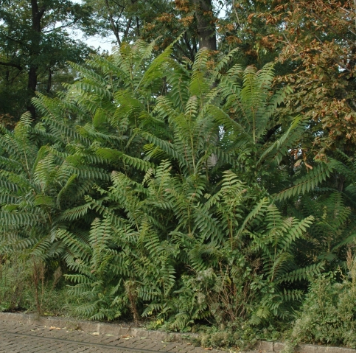
Photo by Chris Evans, University of Illinois

