Hawkweeds

  - Hieracium spp.
Sunflower Family

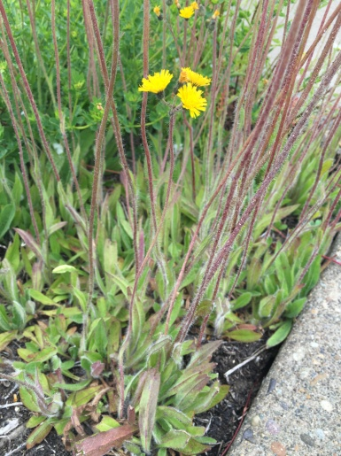
INTRODUCTION

Identification Tips
- Hawkweeds are perennials in the sunflower family with milky juice, yellow or orange dandelion‐like flower heads, and bristly hair overall.
- Plants have rosettes of strap or lance‐shaped leaves at the base of the stem. The basal leaves of most non‐native hawkweeds usually persist through flowering.
- Some, but not all, non‐native hawkweeds have stolons (runners), allowing for aggressive vegetative reproduction. No native Pacific Northwest hawkweed species have stolons.
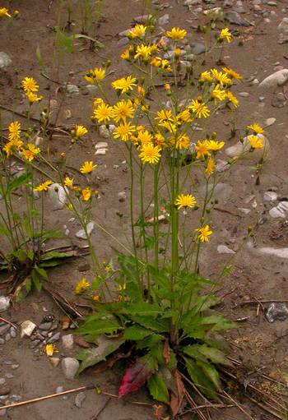
- For more information and help deciphering between native and non-native hawkweeds, please refer to the Key to Identification of Invasive and Native Hawkweeds (Hieracium spp.) in the Pacific Northwest (referenced below).
Meadow/yellow hawkweed

Impacts

Many hawkweeds are allelopathic. They put toxins in the soil which prevents the growth of other plants.
- As a result of prolific seed and stolon production, hawkweeds are successful competitors, crowding out native, ornamental, pasture, and crop species.
- Hawkweeds reduce forest forage.

Habitat & Distribution
- Hawkweeds prefer full sun or partial shade and soil that is well‐drained, coarse-textured, and moderately low in organic matter.
Common hawkweed
- They are mostly found on roadsides and in fields, pastures, and mountain meadows.
- Hawkweeds can tolerate some shade and grow in forest openings and cleared areas.
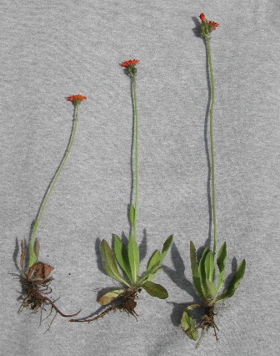
- Orange hawkweed is sometimes found in residential yards where it escapes from intentional plantings or was introduced as part of a “wildflower meadow mix.” It is illegal to sell orange hawkweed or orange hawkweed seeds in Oregon and Washington.
- Hawkweeds can be found from sea level to high elevations and are most abundant at middle elevations in the mountains and along roadsides.

Reproduction & Spread
- Hawkweeds are perennials that reproduce by seed. Many also spread out vegetatively through stolons, rhizomes, and axillary buds from root crowns. Also, hawkweeds can produce viable seed without cross-pollination.
Orange hawkweed
- Most hawkweed species flower in late May or early June.
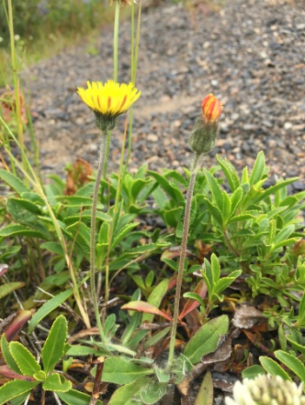
- Plants go to seed starting in June but may continue to flower and go to seed through September.
- Motor vehicles are the primary mode of spread in the Pacific Northwest.

CONTROL INFORMATION

Integrated Pest Management
- The preferred approach for weed control is Integrated Pest Management (IPM). IPM involves selecting from a range of possible control methods to match the management requirements of each site. The goal is to maximize effective control and to minimize negative environmental, economic, and recreational impacts.
Mouseear hawkweed
- Use a multifaceted and adaptive approach. Select control methods reflecting the available time, funding, and labor of the participants, the land use goals, and the values of the community and landowners. Management will require dedication for a number of years and should allow flexibility in methods.

Planning Considerations
- Survey the area for weeds, set priorities, and select the best control method(s) for the site.
- Minimize soil disturbance to prevent further infestations of weeds.
- Begin work on the perimeter of the infested areas first and move inward toward the core of the infestation.
- Monitor the site and continue to treat plants that germinate from the seed bank.
- Revegetate treatment areas to improve ecosystem function and prevent new infestations.

Early Detection and Prevention
- Minimize soil disturbance from vehicles, machinery, and over-grazing to reduce areas where weeds may become established.
- Hawkweeds are difficult to spot in tall grass unless they are in flower. Survey pasture areas, unmanaged grasslands, and roadsides for flowering and pre‐flowering plants from mid-May to late June. Small, isolated populations can be dug up, but the site should be monitored for several years for plants growing from fragments and from the seed bank.
- Ensure any existing plants do not produce and release seed.
- Cut and bag seed heads from plants to prevent seed spread.
- Thoroughly clean tools, boots, and vehicles after working in or traveling through an infested area to prevent the spread of noxious weeds.

Manual, Mechanical, & Cultural Control
- Dig up plants in the spring or early summer when the soil is still moist and before the seeds mature. The roots are fibrous and relatively easy to dig up but break easily. It is important to remove as much root as possible. Hawkweeds with stolons will re‐sprout from any fragments left in the soil.
- Cut off and bag all flower heads because they can form viable seeds even after they are cut or dug up. If there are already seeds, cut and bag the seed heads before digging up the rest of the plant. It is very difficult to pull the plants without dispersing the small, lightweight seeds. Brush off boots and clothes before leaving the infested area.
- Carefully monitor areas where mature plants have been dug up to prevent new infestations. If possible, plant with grass or other competitive vegetation.
- Infested areas typically have many seedlings and an extensive seed bank.
- Mowing will not control hawkweeds because they are perennials and most reproduce by stolons as well as seed. Mowed plants respond by sending up shorter stems and quickly flowering again. Plants will also put more energy into spreading by stolons and the infestation size and density will increase.
- A single plowing may increase hawkweed cover, but on productive agricultural sites, an intensive management program that combines cultivation and annual crops will effectively control hawkweed.
- In pasture settings, placing a salt block inside infestations can reduce patches by encouraging trampling.

Disposal Methods
- Bag all flower heads. If the plants are in seed, carefully cut off the seed head and place in a bag without dispersing the seeds.
- Dispose of flower heads and plants in household garbage or take to a transfer station for disposal. Do not compost or put in yard waste.
- Never dump yard debris in natural areas.

Biological Control
- There are no biological controls currently available for hawkweeds.

Herbicide Control
- Only apply herbicide at proper rates and for the site conditions or land usage specified on the label. Follow all label directions and wear recommended personal protective equipment (PPE).
- Some herbicides are toxic to fish and other aquatic invertebrates and/or may easily injure non-target species like crops growing nearby because of volatilization. Always read and follow the label to avoid environmental and unintended damages.
- Monitor treated areas for missed and newly germinated plants.
- Choose selective herbicides over non-selective herbicides when applying in a grassy area.
- Minimize impacts to bees and other native pollinators by controlling weeds before they flower. When possible, make herbicide applications in the morning or evening when bees are least active. Avoid spraying pollinators directly.

Specific Herbicide Information
Herbicides are described here by the active ingredient. Many commercial formulations are available that contain specific active ingredients. References to product names are for example only. Directions for use may vary between brands.
- Triclopyr (e.g. Brush‐B‐Gon, Vastlan,) is very effective on most hawkweed species. Apply to actively growing plants, ideally from spring to early summer before plants are fully in flower. Adding a surfactant is strongly recommended.
- 2,4‐D alone does not provide good hawkweed control. Combinations of 2,4‐D with other selective herbicides such as dicamba (e.g. Weed‐B‐Gon, Weedmaster) or triclopyr (e.g. Crossbow) are effective.* Apply to actively growing plants before buds form usually before mid-May, later at higher elevations.
- *Please use care when using herbicides that may volatize to form a vapor that can drift during weather inversions or when the temperatures are above 80°F. These herbicides (e.g. 2,4-D, dicamba, etc.) may damage desirable nearby non-target plants or crops following an application. For more information, and to minimize risk, always read and follow the label.

Contractors/Licensed Applicators
- Aminopyralid (e.g. Milestone) is very effective on all hawkweed species. Use the product appropriate for the site: right‐of‐way, non‐crop, or pasture. This herbicide is not available for residential or commercial turf applications.
- Clopyralid (e.g. Transline) may be applied to actively growing plants before the buds form (usually before mid‐May, later at higher elevations). This herbicide is not available for residential or commercial turf applications.

  - This BMP does not constitute a formal recommendation. When using herbicides, always consult the label. Please refer to the Pacific Northwest Weed Management Handbook or contact your local weed authority.

Resources

http://columbiagorgecwma.org/weed-listing/best-management-practices/hawkweeds/

http://hortsense.cahnrs.wsu.edu/Home/HortsenseHome.aspx
https://www.for.gov.bc.ca/hfp/publications/00230/Hawkweed%20key_PNW_R3-June06.pdf

http://wric.ucdavis.edu/information/natural%20areas/wr_H/Hieracium.pdf

http://www.co.jefferson.wa.us/WeedBoard/pdfs/BestManagementPractices/Hawkweed.pdf

http://www.co.lincoln.wa.us/WeedBoard/biocontrol/ORANGE%20HAWKWEED%20BROCHURE.pdf

http://www.msuextension.org/invasiveplants/documents/mt_noxious_weeds/orange_and_meadow_hawkweed.pdf

http://www.msuinvasiveplants.org/noxioussub.html

http://www.nwcb.wa.gov

