Ivy

  - Hedera helix L.
Hedera hibernica
Hedera colchica
Aralia Family

INTRODUCTION
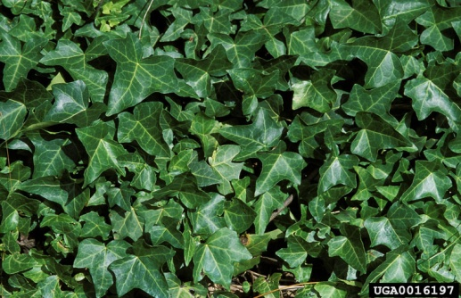

Identification Tips
- Ivy is an evergreen climbing vine that attaches to the bark of trees, brickwork, and other surfaces by way of small root-like structures.
- Older stems have been reported to reach 1 foot in diameter. Leaves are dark green with white veins, waxy to somewhat leathery, and arranged alternately along the stem.

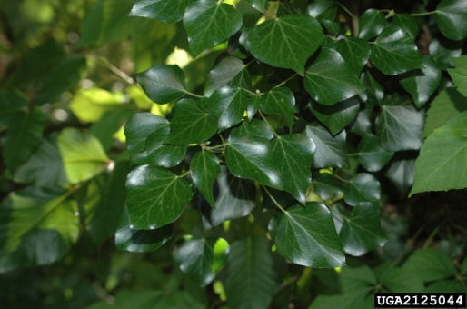
Impacts
- Aggressive in its spread, ivy displaces native plants, eliminating beneficial habitat, and creating areas for unwanted rodents.

Habitat & Distribution
- Ivy infests woodlands, forest edges, fields, hedgerows, coastal areas, salt marsh edges, and other upland areas, especially where some moisture is present.
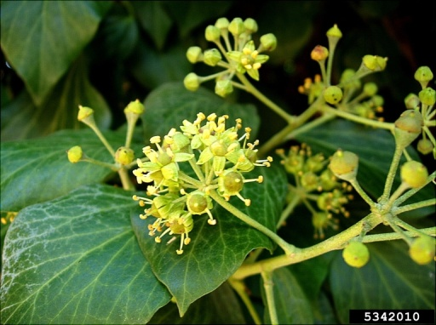
- It thrives in a wide range of soil pH but prefers slightly acidic soils.
- It is often associated with land disturbance, either human-caused or natural.

Reproduction & Spread
- Ivy spreads locally through vegetative regrowth. New plants can grow from cut or broken pieces of stem.
- Ivy disperses longer distances via seed that’s carried to new areas by birds.

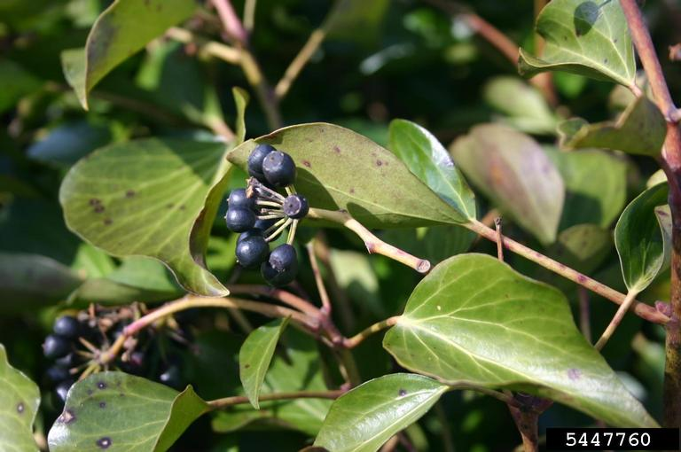
CONTROL INFORMATION

Integrated Pest Management
- The preferred approach for weed control is Integrated Pest Management (IPM). IPM involves selecting from a range of possible control methods to match the management requirements of each specific site. The goal is to maximize effective control and to minimize negative environmental, economic, and recreational impacts.
- Use a multifaceted and adaptive approach. Select control methods reflecting the available time, funding, and labor of the participants, the land use goals, and the values of the community and landowners. Management will require dedication for a number of years and should allow flexibility in methods.
Planning Considerations
- Survey the area for weeds, set priorities, and select the best control method(s) for the site.
- Control practices should be selected to minimize soil disturbance. Minimizing disturbance prevents further infestations of weeds.
- Begin work on the perimeter of the infested areas first and move inward toward the core of the infestation.
- Monitor the site and continue to treat plants that germinate from the seed bank.
- Re-vegetate treatment areas to improve ecosystem function and prevent new infestations.

Early Detection and Prevention
- Dig or pull isolated or small populations before the infestation spreads.
- Ivy produces seeds on mature climbing stems. Prevent the spread of ivy seed by cutting a 12” gap in climbing stems.
- Large infestations may require the careful use of an appropriate herbicide.
- Monitor for new plants and re-treat as necessary. Ensure any existing plants do not produce and release seed. Remove, bag, and dispose of plants and seeds as trash, or burn them.
- Prevent the additional spread of ivy by thoroughly cleaning tools, boots, and vehicles after working in or traveling through an infested area.
- Do not buy ivy at nurseries or garden centers; consider planting comparable non-invasive plants.

Manual, Mechanical, & Cultural Control
- Invasive ivy can be dug or pulled out by the roots when soil is moist. When digging plants, be sure to remove the entire root. You may need to use tools such as pulaskis or pickaxes.
- Bag and dispose of removed plants as trash. Composting is not advised, as root fragments can generate new growth after removal. If you have too much to bag, pile it onto a tarp to prevent re-rooting and allow it to die completely (may take many months).
- If the ivy is climbing trees, pry small vines off the bark with a large screwdriver. Cut large vines with loppers or a saw and pull the vines away from the base of the tree. If plants are on the ground they may be hand-pulled with some difficulty.
- For large infestations, chop through ivy roots in a line and then peel back the mat into a large roll. English ivy will re-grow from root fragments, so repeated pulling will be needed.
- Monitor the site regularly and remove any new growth; vigilance is required to ensure long term control.
- Mulching may be an effective choice for smaller infestations. Cover entire infestation with cardboard and several inches of mulch. These may include wood chips, grass clippings, or hay. Keep the mulch in place for at least 2 growing seasons.

Disposal
- Improper disposal of this plant is a primary cause of recurrent infestations.
- Home compost does not get hot enough to kill plants or seeds of invasive ivy. Bag plant material and place in trash.
- Monitor yard debris for escaped weeds.
- Never dump yard debris in natural areas.

Herbicide Control
- Only apply herbicides at proper rates and for the site conditions or land usage specified on the label. Follow all label directions and wear recommended personal protective equipment (PPE).
- Some herbicides are toxic to fish and other aquatic invertebrates and/or may easily injure non-target species like crops growing nearby because of volatilization. Always read and follow the label to avoid environmental and unintended damages.
- Ivy in treated areas should not be mowed until after the herbicide has taken effect and weeds are brown and dead.
- Monitor treated areas for missed and newly germinated plants. To prevent re-infestation by birds, sites should be monitored once or twice a year.
- Selective herbicides are preferred over non-selective herbicides when applying in a grassy area.
- Minimize impacts to bees and other pollinators by controlling weeds before they flower. If possible, make herbicide applications in the morning or evening when bees are least active. Avoid spraying pollinators directly.

Specific Herbicide Information
Herbicides are described here by the active ingredient. Many commercial formulations are available containing specific active ingredients. References to product names are for example only. Directions for use may vary between brands.
- Glyphosate (Roundup), triclopyr (Vastlan), or a mix of glyphosate + triclopyr (e.g. Ortho MAX Poison Ivy & Tough Brush Killer) can be applied during a sunny period in winter, ideally early to mid January, when temperatures are above 50 degrees, to avoid harming native species.
- An application of glyphosate + triclopyr can also be effective when applied directly after string trimming.
- Two applications of 2,4-D,* one month apart, provides good control in early summer and on regrowth in the late summer.
- *Please use care when using herbicides that may volatize to form a vapor that can drift during weather inversions or when the temperatures are above 80°F. These herbicides (e.g. 2,4-D, dicamba, etc.) may damage desirable nearby non-target plants or crops following an application. For more information, and to minimize risk, always read and follow the label.
- Ivy can take several months to die after an application.
- For larger infestations, the site should be replanted with the appropriate native vegetation to stabilize the soil surface.
Contractors/Licensed Applicators
- Recent trials in Portland found a 4-2-2 application method to be 95+% effective. This mix is 4% glyphosate, 2% triclopyr (Garlon 3A), and 2% surfactant (Competitor).

  - This BMP does not constitute a formal recommendation. When using herbicides, always consult the label. Please refer to the Pacific Northwest Weed Management Handbook or contact your local weed authority.

Resources

http://columbiagorgecwma.org/weed-listing/best-management-practices/english-ivy/

http://hortsense.cahnrs.wsu.edu/Home/HortsenseHome.aspx

http://www.kingcounty.gov/environment/animals-and-plants/noxious-weeds/weed-control-practices/bmp.aspx

http://www.nwcb.wa.gov

http://www.nwcb.wa.gov/images/weeds/English-Ivy_201303061430585035_Cowlitz.pdf

http://www.oregon.gov/ODA/programs/Weeds/Pages/EnglishIvyForum.aspx

