Meadow Knapweed
  - Centaurea x gerstlaueri
Sunflower Family

INTRODUCTION
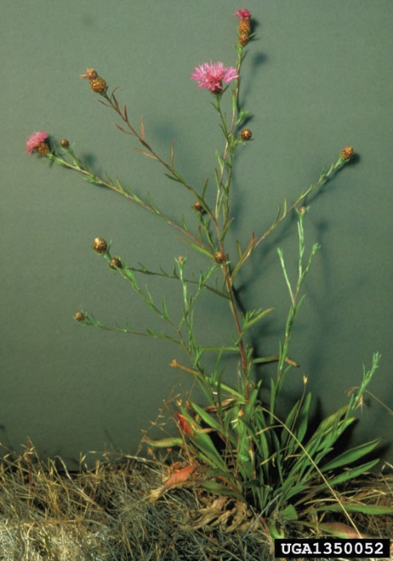

Identification Tips

Meadow knapweed is an herbaceous perennial growing from a woody root crown. It forms a rosette in the first autumn of growth before bolting the following spring. It is a hybrid of brown and black knapweed, both from Europe.
- It grows up to 40 inches tall from a main stem with several spreading branches and a long taproot.
- The flowers are usually pink to purple and grow at the end of branches. They typically begin blooming in June and may continue through September.

Impacts

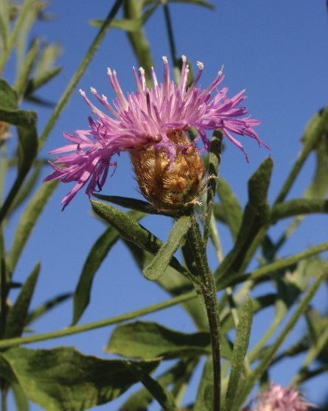
Meadow knapweed competes with grasses and other pasture species and is highly invasive on disturbed soils, reducing forage for wildlife and livestock.
- It is difficult to remove once established.

Habitat & Distribution
- Meadow knapweed has become a significant problem on the west side of the Cascades where it’s much more aggressive than in the east. It is commonly found on moist sand, gravel riverbanks, roadsides, forest openings, moist meadows, and irrigated pastures. It also establishes quickly in newly disturbed areas.

Reproduction & Spread
- Meadow knapweed reproduces primarily by seed.
- Seeds are ivory-white to light brown and wind-dispersed.

CONTROL INFORMATION

Integrated Pest Management
- The preferred approach for weed control is Integrated Pest Management (IPM). IPM involves selecting from a range of possible control methods to match the management requirements of each specific site. The goal is to maximize effective control and to minimize negative environmental, economic, and recreational impacts.
- Use a multifaceted and adaptive approach. Select control methods reflecting the available time, funding, and labor of the participants, the land use goals, and the values of the community and landowners. Management will require dedication for a number of years and should allow flexibility in methods.

Planning Considerations
- Survey the area for weeds, set priorities, and select the best control method(s) for the site.
- Select control practices to minimize soil disturbance. Minimizing disturbance prevents further infestations of weeds.
- Begin work on the perimeter of the infested area first and move inward toward the core of the infestation.
- Monitor the site and continue to treat plants that germinate from the seed bank.
- Re-vegetate areas where weeds have been removed to improve ecosystem function and prevent new infestations.

Early Detection and Prevention
- Minimize soil disturbance from vehicles, machinery, and overgrazing to reduce areas where weeds may become established.
- Meadow knapweed is easiest to identify in June or July, when the flowers have started to form. Conduct a site survey to determine treatment needs.
- Small infestations can be managed by hand pulling or digging plants out by the roots.
- Larger infestations may require the proper use of an appropriate herbicide.
- Monitor for new plants and re-treat as necessary. Prevent existing plants from producing and releasing seed.
- Prevent the spread of meadow knapweed by thoroughly cleaning tools, boots, and vehicles after working in or traveling through an infested area.

Manual, Mechanical, & Cultural Control
- Manual control of meadow knapweed can be used in combination with other control methods. Knapweed can be dug by the root before seed-heads begin forming.
- If plants are dug after flowers have formed, bag the flower heads and place in the municipal waste, as seed can continue forming even after plants have been uprooted.
- Mowing is not an effective control method, as new growth can form within the same season. In addition, mowing may encourage more stem growth.
- Tilling and cultivation that buries seed and plant matter below a depth of one and a half inches may be effective, especially if the area is replanted with a healthy cover crop.
- Avoid soil disturbance and re-vegetate disturbed areas to prevent knapweed infestations.
- Use proper grazing practices and seed rangeland with native species to prevent infestations and contribute to healthy and weed-free rangeland.

Biological Control
Biological control is the deliberate introduction of insects, mammals, or other organisms which adversely affect the target weed species. Biological control is most effective when used in conjunction with other control techniques.
- A seed-feeding weevil (Larinus obtusus) is being used as a biocontrol agent in Oregon and Washington. For more information on this program, contact your local weed authority.

Herbicide Control
- Only apply herbicides at proper rates and for the site conditions or land usage specified on the label. Follow all label directions and wear recommended personal protective equipment (PPE).
- Some herbicides are toxic to fish and other aquatic invertebrates and/or may easily injure non-target species like crops growing nearby because of volatilization. Always read and follow the label to avoid environmental and unintended damages.
- Monitor treated areas for missed and newly-germinated plants.
- Selective herbicides are preferred over non-selective herbicides when applying in a grassy area.
- Minimize impacts to bees and other pollinators by controlling weeds before they flower. If possible, make chemical applications in the morning or evening when bees are least active. Avoid spraying pollinators directly.

Specific Herbicide Information
Herbicides are described here by the active ingredient. Many commercial formulations are available containing specific active ingredients. References to product names are for example only. Directions for use may vary between brands.
- For best results, use aminopyralid (Milestone) from early bud stage through flowering and on dormant plants in the fall.
- A foliar spray of selective broadleaf herbicides containing 2,4-D* may be effective at an early stage of bolting. *Please use care when using herbicides that may volatize to form a vapor that can drift during weather inversions or when the temperatures are above 80°F. These herbicides (e.g. 2,4-D, dicamba, etc.) may damage desirable nearby non-target plants or crops following an application. For more information, and to minimize risk, always read and follow the label.
- Non-selective herbicides containing glyphosate (Roundup) can be used if damage to nearby grasses can be tolerated. Applications should be made when the plants are actively growing.

  - This BMP does not constitute a formal recommendation. When using herbicides, always consult the label. Please refer to the Pacific Northwest Weed Management Handbook or contact your local weed authority.

Resources

http://columbiagorgecwma.org/weed-listing/best-management-practices/knapweeds/

http://hortsense.cahnrs.wsu.edu/Home/HortsenseHome.aspx

http://wric.ucdavis.edu/information/natural%20areas/wr_C/Centaurea_debeauxii.pdf

http://www.co.jefferson.wa.us/WeedBoard/pdfs/BestManagementPractices

http://www.ipm.ucdavis.edu

http://www.kingcounty.gov/environment/animals-and-plants/noxious-weeds/weed-control-practices/bmp.aspx

http://www.nwcb.wa.gov
