Puncturevine

  - Tribulus terrestris
Sunflower Family

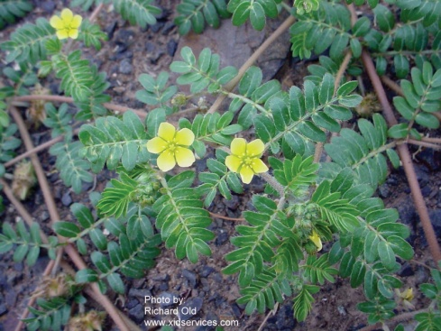
INTRODUCTION

Identification Tips
- Puncturevine is a summer annual which grows prostrate along the ground. Herbaceous stems radiate out from a simple, woody taproot.
- Small, yellow flowers borne on short stalks at leaf nodes. Solitary flowers have 5 petals, 5 sepals, and 10 stamens.
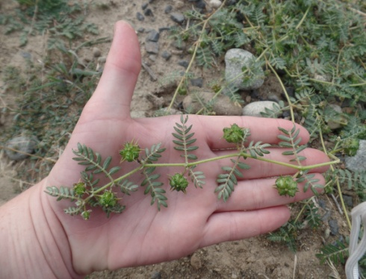
- Feathery leaves are opposite, oblong, and have short stalks.
- Stems are numerous and up to 6 feet long, forming a dense mat.
- The seed is a woody burr with sharp, rigid spines strong enough to puncture bike tires!

Impacts
- Puncturevine is toxic to sheep.
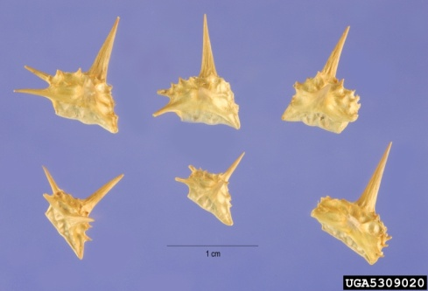
- Sharp burrs injure the feet, hides, mouths, eyes, and digestive tracts of livestock. Those burrs can also injure people. They are especially problematic to fruit pickers working in orchards and vineyards.
- With a deep taproot, puncturevine competes aggressively for water and nutrients in tree and field crops.

Habitat & Distribution
- Puncturevine is a serious weed in pastures, roadsides, waste places, and cultivated fields.

Reproduction & Spread
- Puncturevine reproduces by seed. A typical plant will produce 200 to 5,000 seeds.
- The seeds are dispersed when burrs stick into tires, shoes, clothing, fur, feathers, and animal feet.
- Puncturevine seeds can remain dormant in the soil for many years.
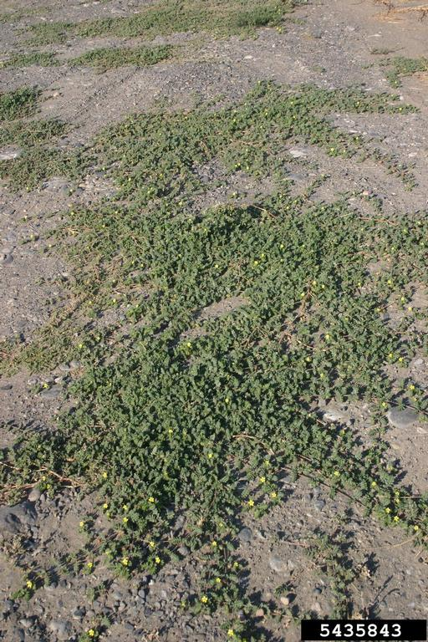

CONTROL INFORMATION

Integrated Pest Management
- The preferred approach for weed control is Integrated Pest Management (IPM). IPM involves selecting from a range of possible control methods to match the management requirements of each specific site. The goal is to maximize effective control and to minimize negative environmental, economic, and recreational impacts.
- Use a multifaceted and adaptive approach. Select control methods reflecting the available time, funding, and labor of the participants, the land use goals, and the values of the community and landowners. Management will require dedication for a number of years and should allow flexibility in methods.

Planning Considerations
- Survey area for weeds, set priorities, and select the best control method(s) for the site.
- Control practices should be selected to minimize soil disturbance. Minimizing disturbance avoids creating more opportunities for weed seed germination.
- Begin work on the perimeter of the infested areas first and move inward toward the core of the infestation.
- Monitor the site and continue to treat plants that germinate from the seed bank.
- Re-vegetate treatment areas to improve ecosystem function and prevent new infestations.

Early Detection and Prevention
- The best method for controlling puncturevine is to prevent its establishment by destroying new plants, preventing burr formation, and promoting competition by planting a healthy stand of grass or forbs.
- Minimize soil disturbance from vehicles, machinery, and overgrazing to reduce seed germination.
- Prevent the spread of puncturevine by checking shoes, tools, and tires for burrs and removing them before travelling to uninfested areas.
- Large infestations may require the careful use of an appropriate herbicide.
- After puncturevine treatments, re-plant the site to prevent re-infestation.
- Dispose of plants properly, preferably by burning. Seeds should be disposed of in the municipal waste and NEVER composted.

Manual, Mechanical, & Cultural Control
- Puncturevine may be hand-pulled prior to seed-set. Wear gloves and remove all spiny burrs from the ground. Dispose of all material properly.
- Shallow tilling in the spring will prevent seed formation.
- Mowing is not recommended due to the low growth form of puncturevine.
- Use mulch to control common puncturevine in ornamental plantings, orchards, vineyards, vegetable crops, and gardens, if they screen out all light. To be effective, organic mulches should be at least 3 inches thick. Puncturevine burrs that fall onto mulch surfaces can establish on the mulch surface due to the plant’s deep taproot.
- Aerate compacted soils and plant competitive desirable plants to reduce the impact of puncturevine.

Biological Control
Biological control is the deliberate introduction of insects, mammals, or other organisms which adversely affect the target weed species. Biological control is generally most effective when used in conjunction with other control techniques.
- The puncturevine seed weevil, Microlarinus lareynii, and the puncturevine stem weevil, Microlarinus lypriformis are two agents that can provide good control when used together.
- The puncturevine seed weevil larvae eat developing seeds and the adults cause damage by feeding on stems, leaves, flowers, and fruits.
- The puncturevine stem weevil larvae feed within the stems and root crowns, while adults feed on the stems and leaves.
- Both of these insects are more difficult to establish in areas with cold winters.
- For more information about the biological control of puncturevine, please contact your local weed authority.

Herbicide Control
- Only apply herbicides at proper rates and for the site conditions or land usage specified on the label. Follow all label directions and wear recommended personal protective equipment (PPE).
- For control of large infestations, herbicide may be required.
- Some herbicides are toxic to fish and other aquatic invertebrates and/or may easily injure non-target species like crops growing nearby because of volatilization. Always read and follow the label to avoid environmental and unintended damages.
- Monitor treated areas for missed and newly germinated plants.
- Selective herbicides are preferred over non-selective herbicides when applying in a grassy area.
- Minimize impacts to bees and other pollinators by controlling weeds before they flower. If possible, make herbicide applications in the morning or evening when bees are least active. Avoid spraying pollinators directly.

Specific Herbicide Information
Herbicides are described here by the active ingredient. Many commercial formulations are available containing specific active ingredients. References to product names are for example only. Directions for use may vary between brands.
- After plants have emerged from the soil (post-emergent), products containing 2,4-D* amine (best), glyphosate, and dicamba are effective on puncturevine. The smaller or younger the plant, the better the post-emergent herbicides work.
- *Please use care when using herbicides that may volatize to form a vapor that can drift during weather inversions or when the temperatures are above 80°F. These herbicides (e.g. 2,4-D, dicamba, etc.) may damage desirable nearby non-target plants or crops following an application. For more information, and to minimize risk, always read and follow the label.
- Persistence is key. Monitor the site multiple times throughout the growing season and re-treat as necessary until first frost.

Contractors/Licensed Applicators
- For right-of-way control, pre-emergent herbicides containing rimsulfuron (Matrix – labeled for tree fruits and vineyards), chlorsulfuron (Telar), or indaziflam (Esplanade or Alion) at 2 oz/acre is effective.

  - This BMP does not constitute a formal recommendation. When using herbicides, always consult the label. Please refer to the Pacific Northwest Weed Management Handbook or contact your local weed authority.

Resources
http://columbiagorgecwma.org/weed-listing/best-management-practices/puncturevine/
https://ag.arizona.edu/yavapai/anr/hort/byg/archive/controllingpuncturevine.html
http://cru.cahe.wsu.edu/CEPublications/PNW0133/PNW0133.pdf
http://hortsense.cahnrs.wsu.edu/Home/HortsenseHome.aspx
http://pnwhandbooks.org/weed/

http://www.ipm.ucdavis.edu/PMG/PESTNOTES/pn74128.html

http://www.co.lincoln.wa.us/WeedBoard/controloptions/puncturevineoptions.pdf
http://www.nwcb.wa.gov

