scotch thistle

  - Onopordum acanthium
Sunflower Family

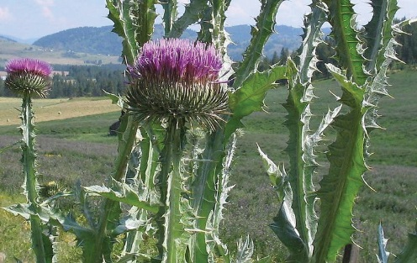
INTRODUCTION

Identification Tips

Scotch thistle is a biennial or sometimes perennial forb, growing to 12 feet tall.
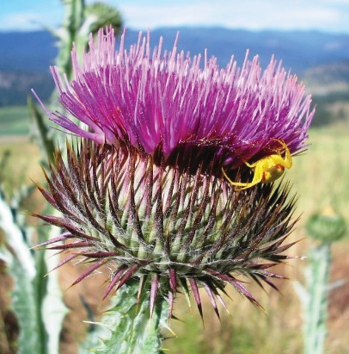
- A spiny, woolly-gray rosette of leaves up to 4 feet wide is formed in the first year. In subsequent years, the 2-foot long, woolly leaves with sharp, yellow spines on the margin are attached to tall, spiny, winged stems. Upper leaves are alternate and coarsely lobed.
- Numerous pink to purple flower heads with spiny bracts at the base occur singly or in clusters of 2 to 3 and are 1 to 2 inches in diameter. It blooms from July to September.
- Seeds are smooth, slender, and plumed.
- Similar in appearance to other thistles, especially the non-native bull thistle (Cirsium vulgare). The large size and winged stem are key identifying traits for Scotch thistle.
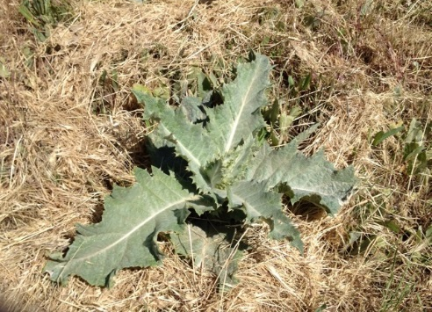
- There are many native thistles to the Pacific Northwest, which are important for pollinators and wildlife. Care should be given to identifying thistles before control measures occur.

Impacts
- Scotch thistle poses a threat in open fields, pastures and rangeland. It reduces forage production for livestock and wildlife.
- Large infestations create impenetrable thickets that prohibit animals from grazing land or getting to water. It can also be a barrier for humans to access trails or stream banks.

Habitat & Distribution
- Scotch thistle prefers full sun, but will grow in either wet meadows or dry grasslands.
- Scotch thistle is native to Europe and Asia but can be found throughout North America. In the Pacific Northwest, small infestations have been detected on the west side of the Cascades, but it is much more common on the east side.

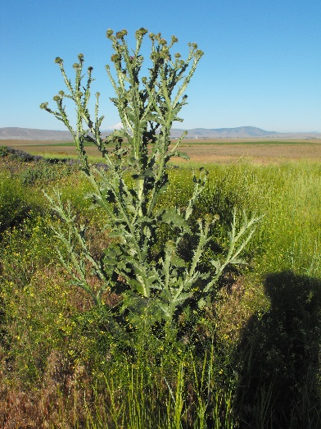
Reproduction & Spread
- A mature plant can produce between 20,000 and 40,000 seeds.
- Seeds dispersed primarily by wind is its only way of reproducing.
- Seeds can remain viable in the soil for at least 7 years.

CONTROL INFORMATION

Integrated Pest Management
- The recommended approach for weed control is Integrated Pest Management (IPM). IPM involves selecting from a broad range of control methods to strengthen the impact of management practices given the ecology of the pest and the specific site conditions where it occurs. The goal of IPM is to maximize effective control and to minimize negative environmental, economic, and recreational impacts.
- Use a multifaceted and adaptive approach. Select control methods reflecting the available time, funding, and labor of the participants, the land use goals, and the values of the community and landowners. Management will require dedication for a number of years and should allow flexibility in methods.
Planning Considerations
- Survey area for weeds, set priorities, and select the best control method(s) for the site.
- Control practices should be selected to minimize soil disturbance. Minimizing disturbance prevents further infestations of weeds.
- Begin work on the perimeter of the infested area first and move inward toward the core of the infestation.
- Monitor the site and continue to treat plants that germinate from the seed bank.
- Revegetate the treatment areas to improve ecosystem function and prevent new infestations.

Early Detection and Prevention
- Scotch thistle is identifiable most of the year.
- Control new infestations as early as possible.
- Minimize soil disturbance from vehicles, machinery, and over-grazing to reduce seed germination.
- Monitor for new plants and re-treat as necessary. Ensure any existing plants do not produce and release seed.
- Beware of fill dirt, hay, and seed that may be contaminated with seeds from invasive weeds.
- Prevent the additional spread of invasive species by thoroughly cleaning tools, boots, and vehicles after working in or traveling through an infested area.

Manual, Mechanical, & Cultural Control
- For small infestations, young plants can be hand-pulled or dug. Severing the roots with a shovel is also effective.
- Mowing alone can reduce the size of the plant and decrease seed production, but it does not kill it.
- If flowers have formed, prevent seed formation and dispersal by cutting flower or seed heads and disposing of them in the garbage, not the compost.
- Monitor site after any treatments for newly germinating seeds.

Biological Control

Non-native plants easily establish large infestations and become widespread in their introduced range because they have no natural enemies as they do in their native range. Biological control deliberately reunites a species with its natural enemies, including insects and pathogens, in hopes of achieving the balance found in the plant’s native range. Biological control is not available for all species and will only reduce seed production or the size of the infestation, not eradicate it. It is generally most effective when used in conjunction with other control techniques.
- There are no biological control agents currently being distributed for Scotch thistle in the Pacific Northwest.
- Goats may be somewhat effective in controlling Scotch thistle. Like mowing, grazing must be continuous, or regrowth will occur. Care should be taken to fence off or protect any native or desirable vegetation.

Herbicide Control
- Only apply herbicides at proper rates and for the site conditions or land usage specified on the label. Follow all label directions and wear recommended personal protective equipment (PPE).
- For control of large infestations, herbicide use may be effective either alone or in combination with mowing. Treated areas should not be mowed until after the herbicide has taken effect and weeds are brown and dead.
- Monitor treated areas for missed and newly germinated plants. Selective herbicides are preferred over non-selective herbicides when applying in a grassy area.
- Minimize impacts to bees and other pollinators by controlling weeds before they flower. If possible, make herbicide applications in the morning or evening when bees are least active. Avoid spraying pollinators directly.

Specific Herbicide Information
Herbicides are described here by the active ingredient. Many commercial formulations are available containing specific active ingredients. References to product names are for example only. Directions for use may vary between brands.

Effectively control Scotch thistle when plants are actively growing in the spring prior to bolting or to rosettes in the fall with a foliar application of any of the following herbicides:
- Aminopyralid + metsulfuron methyl (Opensight)
- Glyphosate (Round-Up)
- Clopyralid + 2,4-D* amine (Curtail)
- Clopyralid (Stinger or Transline)
- The use of a surfactant (Dyne-amic) may be needed, depending on the herbicide formulation chosen.
- Continuously monitor for new plants, especially following any disturbance to the soil such as tilling or construction.
- *Please use care when using herbicides that may volatize to form a vapor that can drift during weather inversions or when the temperatures are above 80°F. These herbicides (e.g. 2,4-D, dicamba, etc.) may damage desirable nearby non-target plants or crops following an application. For more information, and to minimize risk, always read and follow the label.

Contractors/Licensed Applicators
- Opensight at 3 oz/acre
- Aminopyralid (Milestone) at 5 oz/acre with Metsulfuron methyl (MSM 60 or Escort)
- Use a surfactant (Dyne-amic) for maximum effects.

  - This BMP does not constitute a formal recommendation. When using herbicides, always consult the label. There may be grazing or other restrictions; please refer to the label for more information. Other references include the Pacific Northwest Weed Management Handbook or your local weed authority.

Resources
http://columbiagorgecwma.org/weed-listing/best-management-practices/scotchthistle/

http://hortsense.cahnrs.wsu.edu/Home/HortsenseHome.aspx

http://www.nwcb.wa.gov

https://www.nwcb.wa.gov/images/weeds/SCOTCH-THISTLE-BROCHURE_Lincoln.pdf

https://www.nwcb.wa.gov/images/weeds/scotchthistle_pierce.pdf

https://www.nwcb.wa.gov/images/weeds/Scotch-Thistle_2016_Thurston.pdf

https://pnwhandbooks.org/weed/problem-weeds/thistle-bull-cirsium-arvense-milk-silybum-marianum-musk-carduus-nutans-scotch

https://xerces.org/wp-content/uploads/2016/10/2016-029_Native-Thistle-Conservation-Guidelines_FINAL_web.pdf

